Understanding Information Barriers to Regulatory Compliance Among Sri Lankan SMEs
Module 1 — Regulatory Change Awareness Gap · Final Report v2, reconciled to the engineering record of 2 August 2026
Mohomed M.R.I (215075J) — Enigmatrix, Faculty of Information Technology, University of Moratuwa
2 August 2026
Table of Contents

PART II — Module 1 Individual Report (Ifham Mohamed)
Source: G28 - Enigmatrix - Final Report (Module 1 - Ifham Mohamed).docx. Reproduced in full, in document order. Text in backticks such as [ADD SUPERVISOR NAME] are the author’s own unresolved placeholders and are preserved verbatim.
FINAL REPORT
Level 04
Understanding Information Barriers to Regulatory Compliance Among Sri Lankan SMEs
Enigmatrix
215075J Mohomed M.R.I [VERIFY OFFICIAL NAME]
215007F Ahamadh M.S.A [VERIFY TEAM DETAILS]
215008J Ahamed T.I [VERIFY TEAM DETAILS]
[ADD INDEX NO 4] [ADD FULL NAME 4 - delete this line if the group has three members]
Supervised by …………………………………
Supervised by …………………………………
Faculty of Information Technology
University of Moratuwa
[ADD MONTH] 2026
Understanding Information Barriers to Regulatory Compliance Among Sri Lankan SMEs
Enigmatrix
215075J Mohomed M.R.I
215007F Ahamadh M.S.A
215008J Ahamed T.I
[ADD INDEX NO 4] [ADD FULL NAME 4]
Dissertation submitted to the Faculty of Information Technology, University of Moratuwa, Sri Lanka for the partial fulfillment of the requirements of the [ADD DEGREE NAME].
[ADD MONTH] 2026

DECLARATION
We declare that this thesis is our own work and has not been submitted in any form for another degree or diploma at any university or other institution of tertiary education. Information derived from the published or unpublished work of others has been acknowledged in the text and a list of references is given.
…………………………………… 215075J Mohomed M.R.I
…………………………………… 215007F Ahamadh M.S.A
…………………………………… 215008J Ahamed T.I
…………………………………… [ADD INDEX NO 4] [ADD FULL NAME 4]
Date: [ADD DD.MM.YYYY]
Supervised By
…………………………………… [ADD SUPERVISOR NAME]
Date: [ADD DD.MM.YYYY]
…………………………………… [ADD CO-SUPERVISOR NAME]
Date: [ADD DD.MM.YYYY]

ACKNOWLEDGMENT
[ADD ACKNOWLEDGMENT] — Draft to adapt and sign off:
We wish to express our sincere gratitude to our supervisor, [ADD SUPERVISOR NAME], and our co-supervisor, [ADD CO-SUPERVISOR NAME], of the Faculty of Information Technology, University of Moratuwa, for their continued guidance, critical feedback and encouragement throughout this research.
We thank the academic and technical staff of the Faculty of Information Technology for the facilities and academic environment that made this work possible, and the panel members whose feedback at the proposal and interim reviews materially improved the direction of the project.
We are grateful to the domain experts and annotators who contributed to the calibration set and to the dual annotation of the regulatory corpus, and to the small and medium enterprise owners who gave their time to the compliance-awareness survey. Their participation is the foundation of the empirical component of this research.
We acknowledge the providers of the free and academic compute resources used for model training and evaluation, and the maintainers of the open-source software on which this platform is built.
Finally, we thank our families and friends for their patience and support over the course of this project.

ABSTRACT
Sri Lankan small and medium enterprises operate under a regulatory regime that publishes several hundred binding amendments each year through the Official Gazette and departmental portals. These instruments are released as unstructured PDF documents in English, Sinhala and Tamil, without push notification or machine-readable metadata. The consequence is an information asymmetry between the regulator and the regulated enterprise: a rule can be legally in force while the business it binds remains unaware of it, and penalties arising in that window reflect an information failure rather than wilful evasion. This project treats that asymmetry as an engineering problem.
Enigmatrix is a modular, trilingual web platform that converts official regulatory publications into structured, sector-aware and verifiable intelligence for SMEs. It comprises four research modules: regulatory change awareness, compliance knowledge accuracy, compliance risk invisibility and regulatory misinformation verification. All four consume a single verified regulatory data layer produced by the first module.
This dissertation documents the platform and, in detail, Module 1. Four Scrapy spiders collect gazettes, acts and bills. A per-page routing extraction chain built on PyMuPDF, pdfplumber, pypdfium2, Tesseract 5 and Surya OCR, with font-aware Wijesekara-to-Unicode conversion, handles a corpus that is part born-digital English and part scanned legacy-encoded Sinhala and Tamil. Preprocessing performs cleaning, fastText language identification, metadata and penalty extraction, chunking and sub-document splitting. A gold dataset was constructed by dual annotation followed by explicit adjudication. The v1 freeze held 800 records at a category Cohen’s kappa of 0.8715, mean sector kappa 0.8638 and SME-relevance kappa 0.7235; rare-domain top-up batches 06–07 subsequently took the adjudicated gold set to 1,128 records across 2,256 annotations, lifting agreement to category kappa 0.947215, mean sector kappa 0.965567 and SME-relevance kappa 0.914637. The machine-learning branch froze at 1,110 rows after excluding 18 OCR and page-number artefacts, on a fixed 777 / 166 / 167 split. [v2] TF-IDF baselines on the v1 800-row split reached test macro-F1 of 0.4980 for logistic regression and 0.6167 for LinearSVC. On the frozen 1,110-row V6 dataset the same lexical family reached 0.947220 on the temporal test split and was frozen as the production classifier, clearing the 0.92 project gate. A single XLM-RoBERTa encoder with LoRA adapters and a dual head — single-label category by cross-entropy over eight categories, multi-label sector by binary cross-entropy over three sectors — was implemented and trained across three configurations on free GPU runtimes; its best temporal-test macro-F1 was 0.743563 and it was rejected. No ONNX artefact was exported. [v2] Downstream, propagation watchers, an idempotent sector-matched alert dispatcher and nightly lag analytics convert the platform into a research instrument that makes regulatory information diffusion an empirical quantity rather than an anecdote.
The contribution is twofold: an operational, measurable awareness pipeline for Sri Lankan SMEs, and the dataset and instrumentation required to quantify how long regulatory information actually takes to reach them.
Keywords: RegTech, regulatory compliance, SME, information asymmetry, multilingual NLP, XLM-RoBERTa, LoRA, OCR, Sinhala, Tamil, information diffusion.

TABLE OF CONTENT
Right-click here and choose ‘Update Field’
(In Word: click inside the table of contents, press F9, then choose ‘Update entire table’.)

LIST OF FIGURES
Right-click here and choose ‘Update Field’
(Click inside this list and press F9 to populate it.)

LIST OF TABLES
Right-click here and choose ‘Update Field’
(Click inside this list and press F9 to populate it.)

LIST OF ABBREVIATIONS
Table 0.1 — Abbreviations used in this dissertation
Abbreviation | Expansion
API | Application Programming Interface
BCE | Binary Cross-Entropy
CE | Cross-Entropy
CER | Character Error Rate
DFD | Data Flow Diagram
DiD | Difference-in-Differences
ECE | Expected Calibration Error
EPF / ETF | Employees’ Provident Fund / Employees’ Trust Fund
GRC | Governance, Risk and Compliance
IAA | Inter-Annotator Agreement
IRD | Inland Revenue Department
KL | Kullback–Leibler (divergence)
LID | Language Identification
LoRA | Low-Rank Adaptation
MSME / SME | Micro, Small and Medium Enterprise / Small and Medium Enterprise
NLLB | No Language Left Behind (translation model)
NLP | Natural Language Processing
OCR | Optical Character Recognition
ONNX | Open Neural Network Exchange
RAG | Retrieval-Augmented Generation
RBAC | Role-Based Access Control
RegTech | Regulatory Technology
RQ | Research Question
SSE | Server-Sent Events
WER | Word Error Rate
XLM-R | Cross-lingual Language Model — RoBERTa

Chapter 1 - Introduction

1.1 Introduction
Small and medium enterprises are the operating majority of the Sri Lankan economy. They are also the segment least equipped to absorb regulatory change. Compliance is not optional for them: it governs market access, financing, employment obligations, taxation, product standards, import and export permissions and, ultimately, the right to continue trading. Yet the mechanism by which a Sri Lankan SME learns that an obligation has changed is almost entirely informal.
Regulatory change in Sri Lanka is published primarily through the Official Gazette, supplemented by departmental notices, tax circulars, labour regulations, import and export controls and sector-specific standards. These instruments are legally authoritative but were never designed as a communication channel. They are published as unstructured PDF documents, in three languages, with no subscription mechanism, no push notification and no machine-readable metadata describing what changed, who it affects or when it takes effect. A gazette becomes binding on publication regardless of whether any affected business has read it.
Large organisations absorb this cost through dedicated legal, tax, risk and compliance functions. SMEs do not have that capacity. Owners and managers rely on accountants, trade associations, peer networks, messaging groups and social media — channels that are fast but unverified, or reliable but slow and expensive. The result is a lag between legal publication and practical awareness, during which the enterprise is non-compliant without knowing it. Penalties arising in this window are not the product of wilful evasion; they are the product of an information failure.
Enigmatrix is designed around that failure. It is a regulatory intelligence platform that treats the path from official publication to SME action as a measurable pipeline, and attempts to shorten it. The platform detects regulatory changes, structures and classifies them, determines which SME sectors they affect, explains them in plain language in the user’s preferred language, assesses the resulting compliance risk, and verifies the accuracy of compliance claims circulating informally. The project is organised into four research modules so that each contribution is independently measurable while sharing a single verified regulatory data layer.

1.2 Background and Motivation
The motivation for this project is the mismatch between how regulation is published and how it is consumed.
Official regulatory documents are optimised for legal validity, not comprehension. A single gazette issue may contain several unrelated instruments, cross-reference earlier amendments by number, use statutory drafting conventions, and appear as a scanned image rather than selectable text. Sinhala and Tamil issues frequently use legacy font encodings — notably Wijesekara — that render correctly on screen but produce meaningless byte sequences when extracted programmatically, and do so silently. Even once a document is located, the SME owner must still determine four things: whether it applies to their sector, what category of change it represents, what duty or deadline it creates, and what action to take.
Existing approaches address parts of this but not the whole:
- Government portals publish authoritative content but assume the user already knows what to search for and can interpret what they find. Discovery remains a pull operation.
- Professional advisory services — accountants, tax consultants, legal advisers — provide interpretation, but at a cost and cadence many SMEs cannot sustain. Advice typically arrives at filing time, not at publication time.
- Informal channels — peer groups, messaging applications, social media — are fast and free, and are consequently the dominant channel. They are also unverified, and are the primary vector for regulatory misinformation.
- Enterprise GRC and RegTech systems automate regulatory monitoring effectively, but are built for large regulated institutions, assume English-first structured regulatory feeds, and presume in-house compliance staff to act on their output. The research gap is therefore not a missing piece of software; it is a missing measurement. Compliance research establishes that knowledge and tax literacy predict voluntary compliance [22], [23], [24], and the slippery-slope framework explains compliance as a function of trust and enforcement power [25]. But this literature treats knowledge as a static attribute of the owner. It rarely asks how regulatory information physically travelled from the state to the enterprise, how long it took, through which channel, or whether it was distorted in transit. Akerlof’s account of information asymmetry [26] describes exactly this structure: one party holds information the other needs, and the outcome degrades when the transfer fails.
Enigmatrix responds by building the transfer mechanism and instrumenting it. Every stage of the pipeline records a timestamp, every downstream appearance of a regulation on a secondary channel is captured as a propagation event, and the resulting dataset makes the diffusion lag an empirical quantity.

1.3 Problem in Brief
Sri Lankan SMEs lack a timely, reliable, multilingual and sector-aware mechanism for discovering regulatory changes and converting them into practical compliance action.
The problem decomposes into four connected gaps, which map one-to-one onto the four modules of the platform:
- Regulatory change awareness gap (Module 1). SMEs do not reliably learn that a relevant tax, labour, import/export, product-standard or sector rule has changed, and there is no measurement of how long that discovery actually takes.
- Compliance knowledge accuracy gap (Module 2). Even when a regulation is found, its meaning and the required action are not clear to a non-specialist reader.
- Compliance risk invisibility gap (Module 3). SMEs cannot see which of their compliance weaknesses are most urgent, so effort is allocated by anxiety rather than by exposure.
- Regulatory misinformation gap (Module 4). Informal channels circulate inaccurate compliance claims that are indistinguishable, to the recipient, from correct ones.
A system that only stores and displays documents does not close any of these gaps. The platform must convert fragmented regulatory publications into verified, searchable, explainable and enterprise-specific intelligence.

1.4 Aim & Objectives

1.4.1 Aim
To design, implement and evaluate a modular, trilingual regulatory intelligence platform that enables Sri Lankan SMEs to identify, understand, assess and respond to relevant regulatory changes in a timely and trustworthy manner, and to measure the reduction in regulatory information lag that the platform achieves.

1.4.2 Objectives
- To investigate the regulatory information barriers faced by Sri Lankan SMEs — awareness delay, interpretation difficulty, risk prioritisation and misinformation exposure — and to formalise them as measurable research questions.
- To design an end-to-end platform architecture connecting regulatory ingestion, SME profiles, multilingual explanation, knowledge retrieval, risk assessment and misinformation verification over a single verified regulatory data layer.
- To implement a regulatory change awareness module that scrapes, extracts, preprocesses, classifies and structures official regulatory content, including scanned and legacy-encoded Sinhala and Tamil documents.
- To construct a labelled regulatory dataset through dual annotation and adjudication, and to establish its reliability using Cohen’s kappa and field-level reconciliation statistics.
- To train and evaluate baseline and transformer-based models for regulatory change classification and SME sector relevance detection, using macro-F1 as the primary metric under class imbalance.
- To support multilingual regulatory understanding through controlled English summarisation and Sinhala/Tamil translation of titles and summaries.
- To implement propagation watchers, sector-matched alerting and lag analytics so that regulatory information diffusion can be measured empirically.
- To design and implement a sealed-baseline evaluation framework that quantifies extraction and classification accuracy at field, record and stage granularity.
- To provide defined integration points for the compliance knowledge, compliance risk and misinformation verification modules.
- To document the design, implementation, evaluation, limitations and future work in a reproducible dissertation.
The objectives above are operationalised through four research questions for Module 1.
Table 1.1 — Research questions addressed by Module 1
ID | Research question
RQ1 | Can a single trilingual classifier assign gazette changes to an 8-domain, 3-sector taxonomy at a macro-F1 of at least 0.92, with no language slice more than 8 percentage points below the overall score?
RQ2 | Does extraction quality — in particular Sinhala/Tamil OCR and Wijesekara-to-Unicode conversion — support reliable downstream classification?
RQ3 | What is the measured regulatory information-diffusion lag across publication channels in Sri Lanka?
RQ4 | Do targeted, sector-matched alerts reduce that lag relative to the unassisted baseline?

1.5 Proposed Solution
Enigmatrix is a modular web platform composed of a FastAPI backend, a Next.js frontend, relational and vector storage, an asynchronous task layer and a Python machine-learning package. SMEs register with a business profile — sector, region, scale and language preference. Regulatory information is collected from official sources, extracted into structured records, classified by change category and affected sector, summarised into plain language, translated where required, and delivered through dashboards, alerts, search and advisory workflows. Administrative and expert users verify, correct, annotate and measure the pipeline through a dedicated admin surface.
The design principle is that regulatory information is structured once, into a verified regulatory intelligence store, and then reused by every downstream module. Module 1 produces that store; Modules 2, 3 and 4 consume it.

1.5.1 Module 1 — Regulatory Change Awareness Gap
Module 1 is owned by Mohomed M.R.I (215075J). It owns the upstream pipeline and the diffusion-measurement research programme. Its functions are:
- Regulation source management. Administrative CRUD over regulation records and sources, soft deletion via an is_active flag, an expert-verification gate, bulk verification, restore, and audit logging on every mutation.
- Scraping and ingestion. Four Scrapy spiders (gazette, weekly gazette, acts, bills) targeting gazette.lk and documents.gov.lk, with date scoping, English→Sinhala→Tamil fallback, and completeness verification with re-fetch.
- Extraction. A per-document and per-page routing chain that classifies each PDF as text, hybrid or scanned and dispatches to PyMuPDF, pdfplumber, pypdfium2 or Tesseract 5, with a Surya OCR fallback profile and font-aware Wijesekara-to-Unicode conversion.
- Preprocessing. Cleaning, fastText language identification, metadata extraction (gazette number, dates, penalties including the multi-penalty case), chunking and sub-document splitting into a classification_chunk.
- Annotation. A Label Studio project covering 8 domains, 3 sectors, SME relevance, annotator confidence and free-text rationale; a 20-document trilingual calibration set with expert labels; stratified, k-means and hybrid active-learning samplers with minority-domain targeting.
- Gold dataset construction. Dual annotation of batches 02–05, automated reduction through resolve_iaa.py, and manual adjudication of disagreements into a frozen 800-row gold dataset with zero lead-annotator fallback rows.
- Classification. Eight regulatory change categories and three SME study sectors, modelled by TF-IDF baselines and an XLM-RoBERTa encoder with LoRA adapters and a dual head. The transformer was rejected at the bake-off; the frozen production classifier is the TF-IDF + LinearSVC pipeline. [v2]
- Summarisation and translation. Controlled English summary generation from the classified record, and NLLB-200 translation of titles and summaries into Sinhala and Tamil, with an administrative translation review queue.
- Watchers, alerts and analytics. Portal and RSS watchers feeding a propagation-event table via a two-step matcher, an idempotent sector-matched alert dispatcher across in-app, email and SMS channels, and materialised lag-analytics views refreshed nightly.
- Measurement and retraining. A dataset registry with immutable sealed versions, an extraction-profile registry, a measurement engine producing per-field metrics, a downloadable accuracy report, a Kullback–Leibler drift monitor and a canary promotion decision function.
The research contribution of Module 1 is not the classifier alone. It is the construction of a measurable awareness pipeline together with the first instrumented dataset of Sri Lankan regulatory information diffusion.

1.5.2 Module 2 — Compliance Knowledge Accuracy Gap
[M2 PLACEHOLDER]
To be completed by the responsible member. Required content: member name and index number; the exact module aim; knowledge sources and how they are grounded in Module 1’s verified records; the retrieval and question-answering approach; multilingual explanation handling; the knowledge-score survey instrument; and the evaluation method.

1.5.3 Module 3 — Compliance Risk Invisibility Gap
[M3 PLACEHOLDER]
To be completed by the responsible member. Required content: member name and index number; the exact module aim; the SME profile, survey, behavioural and compliance-history inputs; the risk scoring model or rule framework; the explainability method; and the evaluation method.

1.5.4 Module 4 — Regulatory Misinformation Spread Gap
[M4 PLACEHOLDER]
To be completed by the responsible member. Required content: member name and index number; the exact module aim; the claim source and extraction approach; evidence retrieval against the verified corpus; the verdict and confidence scheme; and the evaluation method.

1.5.5 Flow of the Overall System
The platform begins with two inputs: official regulatory publications and SME business profiles. Module 1 converts the former into structured, classified, verified records held in PostgreSQL and mirrored into ChromaDB for retrieval. A personalisation layer joins those records to SME profiles by sector, region and language, and drives alerting. Modules 2, 3 and 4 consume the same verified store for grounded question answering, risk assessment and claim verification respectively. All four surface through a single trilingual frontend, while administrators and domain experts feed corrections, verifications and annotations back into the store. In parallel, propagation watchers observe secondary channels and record when each regulation appears on them, producing the diffusion dataset that answers RQ3 and RQ4.
Mermaid source (renderable at https://mermaid.live) — the authoritative, version-controlled form of this diagram:
flowchart LR
A["Official regulatory sources<br/>gazette.lk, documents.gov.lk<br/>tax, labour, standards notices"] --> B["Module 1<br/>Scrapy ingestion"]
B --> C["Extraction<br/>PyMuPDF / pdfplumber / Tesseract / Surya<br/>Wijesekara to Unicode"]
C --> D["Preprocessing<br/>cleaning, fastText LID, metadata,<br/>penalties, chunking"]
D --> E["Classification<br/>XLM-R + LoRA dual head<br/>8 categories, 3 sectors"]
E --> F["Verified regulatory intelligence store<br/>PostgreSQL + ChromaDB"]
SME["SME profile<br/>sector, region, language, survey data"] --> P["Personalisation layer"]
F --> P
P --> Alert["Sector-matched alerts<br/>in-app, email, SMS"]
F --> M2["Module 2<br/>Compliance knowledge (RAG)"]
SME --> M2
M2 --> Answer["Grounded plain-language guidance"]
SME --> M3["Module 3<br/>Compliance risk assessment"]
F --> M3
M3 --> Risk["Risk profile and priority actions"]
Claim["Compliance claim from informal channel"] --> M4["Module 4<br/>Misinformation verification"]
F --> M4
M4 --> Verdict["Supported / unsupported / uncertain"]
Alert --> UI["Trilingual SME dashboard"]
Answer --> UI
Risk --> UI
Verdict --> UI
Admin["Admin and expert reviewers"] --> Review["Verify, correct, annotate, audit"]
Review --> F
F --> W["Propagation watchers<br/>portals + RSS"]
W --> Lag["Lag analytics<br/>findings F1-F6"]
Placeholder in the Word original: a grey box awaiting the exported PNG of the Mermaid diagram above.
Figure 1.1 — End-to-end flow of the Enigmatrix regulatory intelligence platform

Chapter 2 - Related Work

2.1 Introduction
This chapter reviews the literature relevant to Enigmatrix and to its four modules. It begins with the SME regulatory-compliance problem in developing economies, where compliance cost, regulatory complexity and limited access to specialist advice interact. It then reviews regulatory technology, information asymmetry, multilingual natural language processing, retrieval-augmented question answering, explainable compliance risk modelling and misinformation detection.
The purpose is not to enumerate existing systems but to locate a gap. The compliance literature explains that knowledge and trust drive compliance; the RegTech literature shows how regulatory text can be processed automatically. Neither measures the movement of regulatory information from publication to SME understanding in a multilingual, low-resource setting. That measurement is what this project adds.

2.2 Overall Related Work

2.2.1 SME compliance behaviour and the knowledge constraint
Research on SME compliance consistently identifies knowledge, complexity and cost as the dominant determinants. Musimenta [22] finds that knowledge requirements, tax complexity and compliance cost jointly explain tax compliance among Ugandan SMEs. Agusti and Rahman [23] reach a comparable conclusion for Indonesian enterprises, linking tax attitude to procedural understanding. Mokoena [24] extends the analysis to tax literacy, amnesty, reward and service delivery, again finding literacy to be a first-order determinant of voluntary compliance. Kirchler et al. [25] provide the theoretical frame through the slippery-slope model, in which compliance is produced either by trust in authorities or by perceived enforcement power.
Sri Lanka-specific evidence points the same way. SMEs constitute the bulk of enterprises but operate under a compliance burden calibrated for larger firms [1], [2], [6]. Regulatory and policy barriers are documented as a constraint on SME digital and commercial development in comparable economies [10], and the OECD identifies regulatory quality and accessibility as a direct determinant of the SME business environment [7]. Financial-compliance studies note that navigating the requirements is itself a specialised skill that SMEs typically lack [4]. Concrete Sri Lankan instruments illustrate the volatility: the Social Security Contribution Levy and successive budget changes altered SME obligations at short notice [3], [8], [9]. Access to finance and the wider business environment reinforce the same constraint [21].
The limitation of this body of work, for the present purpose, is that it treats knowledge as a property of the owner measured at a point in time. It asks whether the owner knows the rule. It does not ask when the rule reached them, through which channel, in which language, or whether it survived transmission intact.

2.2.2 Information asymmetry as the organising theory
Akerlof’s analysis of markets under asymmetric information [26] is the theoretical anchor. Where one party holds material information the other lacks, outcomes degrade irrespective of either party’s intent. Subsequent work applies the framework to pharmaceuticals [27], to the regulator’s own signalling problem [28] and to SME disclosure, where improved information disclosure measurably reduces asymmetry [29].
Applied to regulatory compliance, the asymmetry is between the state and the enterprise. The state discharges its duty by publishing; the enterprise bears the consequence of not receiving. Publication is a necessary but insufficient condition for compliance. Enigmatrix is, in these terms, an intermediary that reduces the asymmetry by making the transfer active, structured and measurable rather than passive and assumed.

2.2.3 Regulatory technology and regulatory NLP
RegTech is the closest technical field. Arner, Barberis and Buckley [11] frame RegTech as the response to escalating compliance scale and complexity following the financial crisis. McKinsey [16] characterises it operationally as software that monitors, manages and reports compliance. Butler and O’Brien [20] argue for semantic technologies and NLP as the means of rendering regulatory content machine-processable.
More recent work operationalises this. Automated compliance-monitoring pipelines have been proposed for PDF ingestion, entity extraction and regulatory-impact assessment [30], [31], and NLP has been applied to uncover latent structure in regulatory corpora [32]. RegNLP [33] investigates retrieval and answer generation over regulatory documents specifically, establishing that regulatory text is amenable to modern information-retrieval and generation methods.
Two limitations recur. First, the target user is an institution — typically a bank — with compliance staff, structured regulatory feeds and English-language source material. Second, evaluation is framed around document-processing accuracy, not around whether the regulated party became aware in time. Neither assumption holds for a Sri Lankan SME reading a scanned Sinhala gazette.

2.2.4 Multilingual and low-resource NLP
Enigmatrix must process English, Sinhala and Tamil. XLM-RoBERTa [19] provides cross-lingual representations trained at scale and is the standard choice for low-resource transfer. For Sinhala specifically, de Silva [5] evaluates pre-trained language models for text classification and finds transformer-based models outperform earlier multilingual baselines. Recent Sinhala and code-mixed work on sentiment, aspect classification and keyword extraction confirms the viability of this family of models on Sri Lankan text [47], [48]. Low-resource fine-tuning strategies for multilingual pre-trained models are documented in the SemEval setting [49], and lifelong-learning approaches address multilingual drift [44]. BERT [43] remains the architectural reference point for the encoder family.
The practical implication is that a single multilingual encoder is preferable to three language-specific pipelines at prototype scale: it shares representation across languages where labelled data is scarce, and it reduces the maintenance surface to one model, one tokenizer and one deployment artefact.

2.2.5 Retrieval-augmented generation for grounded compliance answers
Lewis et al. [17] introduced retrieval-augmented generation as a means of grounding generated text in retrieved evidence. In legal and financial domains, where an unsupported assertion is a liability rather than a stylistic flaw, grounding is essential: CBR-RAG [18] combines case-based reasoning with retrieval for legal question answering, FinSage [46] addresses multi-aspect retrieval over financial filings, and recent systems apply RAG to radio-spectrum regulation [50] and to judicial forensics with explicit trustworthiness constraints [51].
Evaluation methodology has matured alongside. RAGAS [52] and ARES [53] define automated measures of faithfulness, answer relevancy, context precision and context recall; VERA [54] adds validation of retrieval-augmented systems; and a recent survey [55] consolidates trustworthiness criteria.

2.2.6 Explainable risk modelling
Bussmann et al. [12] demonstrate explainable machine learning in credit risk management, and Bonifazi et al. [36] apply interpretable models to SME credit default. SHAP [15] is the dominant attribution method, and its stability in credit-risk settings has itself been studied [39]. Miah et al. [38] extend explainable AI to managerial decision-making in financial organisations. Class imbalance is the recurring methodological obstacle: SMOTE [40] remains the reference oversampling technique, and comparative studies of imbalance handling in fraud and risk detection quantify the trade-offs [37], [41], [42].
The gap is that these models predict credit risk from proprietary financial data. Compliance risk in an SME setting must be inferred from survey responses, behavioural signals and regulatory exposure, which are sparser and noisier.

2.2.7 Misinformation detection
Network-oriented analysis of WhatsApp [13] shows how closed messaging networks amplify unverified claims, and studies of misinformation sharing during COVID-19 [14], [35] and public-health surveys [34] characterise the antecedents and consequences of that behaviour. Technically, transformer-based classifiers [43] and multilingual disinformation detection systems such as PolyTruth [45] provide the modelling foundation, and evidence-grounded retrieval [46] supplies the verification mechanism.
The literature concentrates on political, health and general financial misinformation. Routine regulatory misinformation — “the VAT threshold has changed”, “registration is no longer required” — is under-studied, despite being the category most likely to cause direct financial harm to an SME.

2.2.8 Synthesis
Related work establishes that automated regulatory monitoring is feasible, that multilingual transformers can handle Sinhala and Tamil, that grounded generation can produce trustworthy compliance answers, that risk can be modelled explainably, and that misinformation can be detected. What no existing system does is connect these into a single pipeline for a low-resource, multilingual SME population and measure the resulting change in awareness lag. That is the space Enigmatrix occupies.

2.3 Module-wise Related Work

2.3.1 Module 1 — Regulatory Change Awareness Gap
Module 1’s related work falls into four strands.
RegTech monitoring. Arner et al. [11], McKinsey [16] and Butler and O’Brien [20] collectively justify the premise that regulatory monitoring should be a continuous machine process rather than a periodic human search. Module 1 implements exactly that: scheduled spiders, an automatic extraction and classification chain, and event-driven alerting.
Regulatory document NLP. Automated pipelines for regulatory PDF ingestion, entity extraction and impact assessment [30], [31], [32] and retrieval and generation over regulatory corpora [33] establish that regulatory text is tractable. What they do not address is the document-quality problem that dominates the Sri Lankan case: scanned pages, mixed scripts and legacy font encodings. Module 1’s per-page routing chain, Surya fallback and font-aware Wijesekara conversion are responses to a problem the existing literature largely assumes away.
Multilingual classification. XLM-R [19] and Sinhala classification results [5], [47], [48], [49] justify a single multilingual encoder over per-language models. LoRA adaptation is adopted so that fine-tuning remains feasible on a single free-tier GPU, which is the realistic constraint for a final-year project. The dual head — single-label category with cross-entropy, multi-label sector with binary cross-entropy — reflects the structure of the task rather than an off-the-shelf configuration.
Annotation reliability. Because the labelled dataset becomes ground truth for both training and evaluation, its reliability must itself be reported. Cohen’s kappa is appropriate because it discounts agreement expected by chance. The Module 1 dataset achieves a category kappa of 0.8715, a mean sector kappa of 0.8638 and an SME-relevance kappa of 0.7235 over 800 dual-annotated tasks. The lower relevance figure is informative rather than embarrassing: it quantifies the genuine subjectivity of the SME/non-SME boundary and motivates the resolver rules documented in Chapter 6.
Information diffusion. The compliance literature [22], [23], [24] measures knowledge but not its transit. Module 1’s propagation-event table, two-step matcher and lag analytics constitute a measurement instrument for that transit, answering RQ3 and RQ4.
Module 1 research gap.* Existing RegTech and regulatory-NLP systems can process regulatory text, but there is no evidence of a Sri Lankan, SME-focused, trilingual pipeline that both reduces and measures the delay between official regulatory publication and SME awareness.*

2.3.2 Module 2 — Compliance Knowledge Accuracy Gap
[M2 PLACEHOLDER]
Suggested structure for the responsible member: establish why access to raw regulation is insufficient and plain-language guidance is required, using SME knowledge and literacy studies [22], [23], [24]; justify grounded question answering over verified records using RAG literature [17], [18], [46], [50], [51]; define evaluation using faithfulness, answer relevancy, context precision and context recall [52], [53], [54], [55]; and state the gap.

2.3.3 Module 3 — Compliance Risk Invisibility Gap
[M3 PLACEHOLDER]
Suggested structure for the responsible member: establish why prioritisation rather than enumeration is the requirement; justify explainable risk scoring using [12], [15], [36], [38], [39]; address class imbalance and sparse compliance events [37], [40], [41], [42]; and state the gap.

2.3.4 Module 4 — Regulatory Misinformation Spread Gap
[M4 PLACEHOLDER]
Suggested structure for the responsible member: establish SME dependence on informal channels and the resulting exposure [13], [14], [34], [35]; justify transformer-based and multilingual detection [43], [45]; connect verification to evidence retrieval over Module 1’s verified corpus [46]; and state the gap.

2.4 Summary
The reviewed literature supports four conclusions that shape this project. Compliance failure among SMEs is substantially an information failure, not primarily an intent failure [22]–[26]. Regulatory monitoring can be automated, but existing RegTech assumes institutional users and English structured feeds [11], [16], [20], [30]–[33]. Multilingual transformers are the appropriate modelling family for Sinhala and Tamil regulatory text [5], [19], [47]–[49]. Grounded generation, explainable risk modelling and misinformation detection each have mature methods and evaluation frameworks.
What is absent is integration and measurement. Enigmatrix combines awareness, knowledge, risk and verification over a shared verified data layer, and Module 1 supplies both that layer and the instrumentation needed to quantify whether the information barrier has actually narrowed.

Chapter 3 - Technology Adapted

3.1 Introduction
This chapter records the technologies selected for the platform and the reasoning behind each choice. Selections were driven by four constraints: the source documents are multilingual and frequently scanned; the project must run on student-accessible hardware and free or academic-tier services; every result must be reproducible for examination; and each module must remain operable by a single developer.
Table 3.1 — Technology stack by layer
Layer | Technology
Backend | FastAPI, SQLAlchemy 2.0 async, Alembic, Pydantic v2, Celery + Beat (Redis), slowapi
Scraping | Scrapy — gazette_spider, weekly_gazette_spider, acts_spider, bills_spider
Extraction | PyMuPDF, pdfplumber, pypdfium2, Tesseract 5 (eng+sin+tam), Surya OCR, font-aware Wijesekara→Unicode
NLP / ML | XLM-RoBERTa, PEFT (LoRA), PyTorch, Transformers, scikit-learn, fastText, NLLB-200, ONNX Runtime
Frontend | Next.js 14 App Router, Tailwind with shadcn-pattern HSL tokens, next-intl (EN/SI/TA), TanStack Query, Playwright
Storage | PostgreSQL, ChromaDB, Redis, local object storage
Annotation | Label Studio
Compute | Google Colab GPU, Kaggle Notebooks GPU, local CPU workstation
Deployment | Railway (backend), Vercel (frontend), managed PostgreSQL
Quality | pytest, Playwright, Great-Expectations-style JSON suites

3.2 Programming Languages
The system uses two primary languages. Python 3.12 implements the backend, the asynchronous task layer, the scrapers, the extraction chain and the entire machine-learning package. TypeScript implements the frontend. The split follows the workload: Python has the mature PDF, OCR and deep-learning ecosystem the pipeline depends on, while TypeScript with Next.js provides the server-rendered, internationalised interface the SME-facing product requires.
The repository is a monorepo with git submodules so that the three concerns remain independently testable:
Table 3.2 — Repository components
Component | Purpose
enigmatrix-backend | FastAPI application, Celery tasks, Scrapy spiders, Alembic migrations
enigmatrix-frontend | Next.js 14 application, SME dashboard and admin console
enigmatrix-ml | Installable Python package m1 — extraction, preprocessing, model, evaluation, notebooks
enigmatrix-docs | MkDocs documentation set
research/data | Label Studio configuration, calibration set, annotation batches
scripts | Cross-repository scripts: sampling, IAA resolution, thesis artefact generation, translation
Placing extraction and evaluation in enigmatrix-ml rather than in the backend was deliberate: the ML package is pip-installable and backend-independent, so it can be executed in a Colab or Kaggle notebook without importing the web application. The backend app/extraction/ module is a thin re-export adapter that preserves existing imports and tests.

3.2.1 FastAPI, SQLAlchemy and Celery
FastAPI with SQLAlchemy 2.0 async was selected over Django or Flask for three reasons: native asynchronous request handling suits an I/O-bound workload dominated by scraping and database access; Pydantic v2 provides schema validation and OpenAPI documentation without additional code; and the async ORM allows long extraction transactions without blocking the request loop.
Celery with Redis and Beat provides the task layer. Extraction of a single scanned gazette can take minutes, which is untenable inside a request. Celery also supplies the scheduled cadence the research programme requires.
Table 3.3 — Scheduled task cadence
Task | Schedule
Scraper | every 6 hours
Portal watcher / RSS watcher | every 2 hours (offset)
Retire old dataset versions | 20:30 UTC daily
Refresh lag analytics | 21:00 UTC daily
Retraining | quarterly (1 Jan / Apr / Jul / Oct, 03:00)
Alembic maintains a linear migration chain, slowapi enforces rate limits, and audit logging is written on every authentication event and administrative mutation through a single audit_service.record() entry point that is never bypassed — a requirement for a system whose outputs may be cited as compliance evidence.

3.2.2 Scrapy
Scrapy was chosen over ad-hoc requests scripts for its built-in scheduling, retry, throttling and item-pipeline abstractions. Four spiders cover the source surface, each supporting date scoping, closing on scope exhaustion, and falling back English→Sinhala→Tamil when a language edition is unavailable. Completeness verification and re-fetch endpoints reconcile what was expected against what was retrieved.

3.2.3 PDF extraction and OCR libraries
No single extraction engine handles the Sri Lankan gazette corpus. Documents fall into three classes, and pages within a single document may differ.
Table 3.4 — Extraction engine routing
Class | Characteristics | Engine route
Text PDF | Born-digital, selectable text, usually English | PyMuPDF with TEXTFLAGS_TEXT, then pdfplumber for layout and tables
Hybrid | Mixed selectable and image pages | Per-page routing between text and OCR engines
Scanned | Image-only, frequently Sinhala or Tamil | Tesseract 5 –oem 1 –psm 6 -l eng+sin+tam at 300 dpi; Surya OCR as fallback
A classify_pdf step assigns the route using calibratable thresholds. Extraction profiles are registered and versioned — legacy_v1, page_routing_v1, surya_fallback_v1, wijesekara_routing_v1 — so any measurement run is attributable to a specific configuration.
Wijesekara conversion deserves separate mention. Legacy Sinhala documents encode text in the Wijesekara keyboard layout with non-Unicode fonts. Extracted bytes are meaningless without conversion, and the failure is silent: text appears to extract successfully but is unusable. A font-aware converter detects the encoding from embedded font metadata and maps to Unicode. Residual (cid:…) glyph spans are logged for re-extraction.

3.2.4 fastText
fastText performs language identification. It was preferred over langdetect for short-text stability and for its handling of Sinhala and Tamil scripts.

3.2.5 PyTorch, Transformers and PEFT
XLM-RoBERTa base with LoRA adapters is the classification model. XLM-R [19] covers English, Sinhala and Tamil in one encoder, which is decisive when labelled data per language is limited. Full fine-tuning of a ~270M-parameter encoder is impractical on the available hardware; LoRA injects trainable rank-decomposition matrices into the attention query and value projections and freezes the base weights, reducing trainable parameters by orders of magnitude and making training feasible on a single free-tier GPU. PEFT provides the LoRA implementation; Transformers provides the encoder and tokenizer; PyTorch provides the training loop.

3.2.6 scikit-learn
scikit-learn provides the TF-IDF vectoriser, the logistic-regression and LinearSVC baselines and the metric implementations. Reporting a non-transformer baseline is a methodological requirement rather than a convenience: without it, a transformer macro-F1 has no interpretable scale.

3.2.7 ONNX Runtime
The trained model is exported to ONNX with an optional INT8 quantisation and served on CPU. This removes any GPU requirement from production and keeps hosting within free and hobby tiers.

3.2.8 NLLB-200
NLLB-200 distilled 600M performs English→Sinhala and English→Tamil translation of titles and summaries. It was chosen over commercial translation APIs for cost, reproducibility and offline operation, and over larger NLLB variants because the distilled model fits comfortably in free-tier notebook memory while retaining acceptable quality for short administrative text. All machine translations enter an administrative review queue before being surfaced to SMEs.

3.2.9 TypeScript, Next.js and next-intl
Next.js 14 App Router with server components reduces client bundle size on the content-heavy regulation pages. next-intl provides English, Sinhala and Tamil localisation with script-appropriate fonts. Tailwind with shadcn-pattern HSL tokens gives a trust-oriented palette in light and dark modes. TanStack Query manages server state and cache invalidation for the admin pipeline views, while WebSocket and SSE channels carry live extraction progress.

3.3 Cloud and Compute Platforms
No CUDA device is available locally. The local workstation is therefore used only for pipeline execution, extraction runs, measurement runs, baseline training and a single-epoch smoke test; all transformer training and evaluation is executed on free GPU notebook platforms.
Table 3.5 — Compute platforms and their role in this study
Platform | Hardware | Role in this study
Local workstation | CPU only (torch.cuda.is_available() is False) | Extraction, preprocessing, measurement runs, TF-IDF baselines, CPU training smoke test
Google Colab | T4 / L4 GPU, ephemeral runtime | XLM-R + LoRA training, per-slice evaluation, ONNX export, NLLB translation backfill
Kaggle Notebooks | P100 or 2 × T4 GPU, ~30 GPU-hours per week, 12-hour sessions | Longer multi-seed training runs and repeat experiments where the Colab session limit is binding; dataset versioning through Kaggle Datasets
Railway | Single container (uvicorn + Celery worker + Beat) | Backend deployment
Vercel | Serverless | Frontend deployment
Managed PostgreSQL | — | Production relational store
Colab and Kaggle are complementary rather than redundant. Colab is used for interactive development of the training notebook because the runtime attaches quickly and integrates with Google Drive. Kaggle is used for the longer three-seed runs because its weekly GPU quota and 12-hour session limit accommodate a full multi-seed sweep without re-attaching, and because Kaggle Datasets provides an immutable, versioned home for the frozen 800-row gold dataset and the generated Parquet splits. Both write the same model_registry.json, so results from either platform are directly comparable.

3.4 Other Tools and Applications
Table 3.6 — Supporting tools
Tool | Use
Label Studio | Annotation interface for the 8-domain / 3-sector / SME-relevance / confidence schema
Docker Compose | Local PostgreSQL, Redis and ChromaDB for development
uv | Python environment and dependency-group management (serving, training, research) across a workspace
pytest | Backend and ML unit and integration tests
Playwright | Frontend end-to-end tests
Great-Expectations-style JSON suites | Post-seal data-quality validation of dataset versions
Obsidian | Research knowledge base: session diary, feature register, plans and evidence notes
Git and git submodules | Version control across the monorepo
Mermaid | Diagram source kept in version control alongside the text

3.5 Summary
Each selection follows from a constraint of the problem domain rather than from familiarity. Multi-engine extraction exists because the corpus is heterogeneous. Wijesekara conversion exists because the corpus is partly legacy-encoded. A single multilingual encoder with LoRA exists because labelled data and GPU hours are both scarce. Colab and Kaggle are used because no local GPU exists. ONNX CPU inference exists because production hosting has no GPU. Sealed dataset versions and an atomic evaluation fact table exist because the results must be defensible under examination.

Chapter 4 - Approach

4.1 Introduction
This chapter states, for each module, what it consumes, what it does and what it produces. The platform is a chain: Module 1 turns unstructured official publications into verified structured records, and Modules 2, 3 and 4 each transform those records, joined with SME context, into a different decision-support output. Describing the modules in input–process–output terms makes the dependency explicit and defines the contract each module must honour.

4.2 Module 1 — Regulatory Change Awareness Gap

4.2.1 Input
Table 4.1 — Module 1 inputs
Input | Source | Form
Gazette issues, acts and bills | gazette.lk, documents.gov.lk | PDF; born-digital English, scanned Sinhala and Tamil, some legacy-font encoded
Publication metadata | Source listing pages | Gazette number, document number, publication date, source URL, language edition
SME business profiles | Platform registration | Sector, region, scale, preferred language, alert channel preferences
Secondary-channel content | IRD, EPF, ETF and eROC portals; five news RSS feeds | HTML and RSS items used only for propagation measurement
Annotation ground truth | Label Studio | Dual annotations of change category, affected sectors, SME relevance, confidence, notes
Sealed evaluation baseline | Curated ground-truth workbook | ~800 manually curated field-level records, checksummed

4.2.2 Process
The module executes a five-stage pipeline with a parallel measurement loop.
- Ingest. Date-scoped Scrapy spiders discover and download issues, falling back across language editions, and write a record at status ingested with the raw PDF stored on disk. Completeness verification reconciles the expected issue list against what was retrieved and re-fetches gaps.
- Extract. classify_pdf routes each document — and, in hybrid documents, each page — to a text or OCR engine. Font metadata is inspected and legacy Wijesekara text is converted to Unicode. The record advances to extracted with raw_text, extraction_method, sha256, pdf_pages and language.
- Preprocess. Text is cleaned and Unicode-normalised, the language is confirmed by fastText, metadata is extracted (gazette number, publication and effective dates, penalties including the multi-penalty case), sub-documents are split where one issue carries several independent instruments, and the text is chunked to the model’s 512-token window as classification_chunk. The record advances to preprocessed.
- Classify. The frozen TF-IDF + LinearSVC V6 classifier assigns one of eight change categories [v2] and, in the design though not in the frozen model, a multi-label set of affected sectors. The frozen classifier is category-only and returns sectors: []. It emits an uncalibrated decision margin rather than a probability, so classifier_confidence is NULL on this path and review routing is a margin comparison against a provisional 0.40 threshold; records already marked expert-verified are never overwritten. [v2] The record advances to classified.
- Explain and alert. A controlled English summary is generated from the title, domain, affected sectors, amendment type and cleaned text; the title and summary are translated into Sinhala and Tamil by NLLB-200 and queued for administrative review. The alert dispatcher matches the classified record against SME profiles by sector and emits idempotent in-app, email and SMS alerts.
In parallel, portal and RSS watchers poll secondary channels every two hours and attempt to match observed content back to a known regulation, first on exact gazette number and then on fuzzy title similarity, writing a propagation event on first observation. Nightly jobs refresh the lag-analytics materialised views, and a Kullback–Leibler drift monitor over the confidence distribution triggers retraining when it exceeds 0.15.
Mermaid source (renderable at https://mermaid.live) — the authoritative, version-controlled form of this diagram:
flowchart TD
IN1["Gazette PDFs<br/>EN / SI / TA"] --> S1["Stage 1 - Ingest<br/>Scrapy, date-scoped, completeness verify"]
S1 --> S2["Stage 2 - Extract<br/>classify_pdf route, OCR, Wijesekara conversion"]
S2 --> S3["Stage 3 - Preprocess<br/>clean, fastText LID, metadata, penalties,<br/>sub-documents, chunking"]
S3 --> S4["Stage 4 - Classify<br/>TF-IDF + LinearSVC V6 (frozen)<br/>margin gate 0.40 provisional"]
S4 --> S5["Stage 5 - Explain and alert<br/>summary_en, NLLB si/ta, sector-matched dispatch"]
IN2["SME profiles<br/>sector, region, language"] --> S5
S5 --> OUT1["Classified regulation records"]
S5 --> OUT2["Trilingual SME alerts"]
S2 --> MEAS["Measurement loop<br/>sealed baseline, per-field scoring"]
S3 --> MEAS
S4 --> MEAS
MEAS --> OUT3["Accuracy report"]
IN3["Secondary channels<br/>portals + RSS"] --> WCH["Propagation watchers<br/>every 2 h, two-step matcher"]
OUT1 --> WCH
WCH --> OUT4["Diffusion lag dataset"]
Placeholder in the Word original: a grey box awaiting the exported PNG of the Mermaid diagram above.
Figure 4.1 — Module 1 input, process and output

4.2.3 Output
Table 4.2 — Module 1 outputs
Output | Consumer | Description
Verified regulation records | Modules 2, 3 and 4; SME dashboard | Structured rows with category, affected sectors, SME relevance, confidence, dates, penalties and full text
Trilingual titles and summaries | SME alerts and dashboard | title_en/si/ta, summary_en/si/ta, reviewed before publication
Sector-matched alerts | SME users | Idempotent in-app, email and SMS notifications keyed on regulation × recipient × channel
Propagation events | Research analysis | First-observation timestamps per regulation per secondary channel
Lag analytics views | Findings notebooks | v_m1_regulation_lag_summary, v_m1_channel_effectiveness
Accuracy reports | Examiners and maintainers | Per-field, per-record and per-stage scores with error taxonomy and worst-N leaderboard
Labelled gold dataset | Model training and evaluation | 800 reconciled records with adjudication provenance

4.3 Module 2 — Compliance Knowledge Accuracy Gap
[M2 PLACEHOLDER] — to be completed by the responsible member using the structure below.

4.3.1 Input
[M2 PLACEHOLDER] — verified regulation records from Module 1, SME profile and question text, knowledge-survey responses.

4.3.2 Process
[M2 PLACEHOLDER] — chunking, embedding, retrieval, reranking, grounded answer generation, multilingual rendering.

4.3.3 Output
[M2 PLACEHOLDER] — grounded plain-language answers with cited evidence, knowledge scores.

4.4 Module 3 — Compliance Risk Invisibility Gap
[M3 PLACEHOLDER] — to be completed by the responsible member using the structure below.

4.4.1 Input
[M3 PLACEHOLDER] — SME profile, survey responses, behavioural signals, compliance history, regulatory exposure from Module 1.

4.4.2 Process
[M3 PLACEHOLDER] — feature construction, risk scoring model or rule framework, imbalance handling, explanation generation.

4.4.3 Output
[M3 PLACEHOLDER] — risk score, risk band, prioritised actions with per-factor explanations.

4.5 Module 4 — Regulatory Misinformation Spread Gap
[M4 PLACEHOLDER] — to be completed by the responsible member using the structure below.

4.5.1 Input
[M4 PLACEHOLDER] — user-submitted or collected compliance claims, verified regulation corpus from Module 1.

4.5.2 Process
[M4 PLACEHOLDER] — claim extraction, evidence retrieval, stance or entailment decision, confidence calibration.

4.5.3 Output
[M4 PLACEHOLDER] — verdict (supported / unsupported / uncertain) with cited evidence and confidence.

4.6 Summary
The four modules share one contract: Module 1 guarantees a verified, classified, sector-tagged and language-complete regulation record, and the other three modules build decision support on top of it without re-parsing source documents. This is what allows the platform to be evaluated module by module and still be defensible end to end — each module’s output quality is bounded by, and measured against, the quality of the record it received.

Chapter 5 - Analysis and Design

5.1 Introduction
This chapter presents the design of the platform. Section 5.2 gives the overall architecture together with the data-flow, class, sequence and database designs. Section 5.3 gives the module-level designs, with Module 1 in full detail and structured placeholders for the other modules.

5.2 High-Level Architecture of the Overall System
The platform is designed as a four-layer architecture, with the four research modules occupying the application layer and communicating through a shared event bus and a shared verified knowledge base.
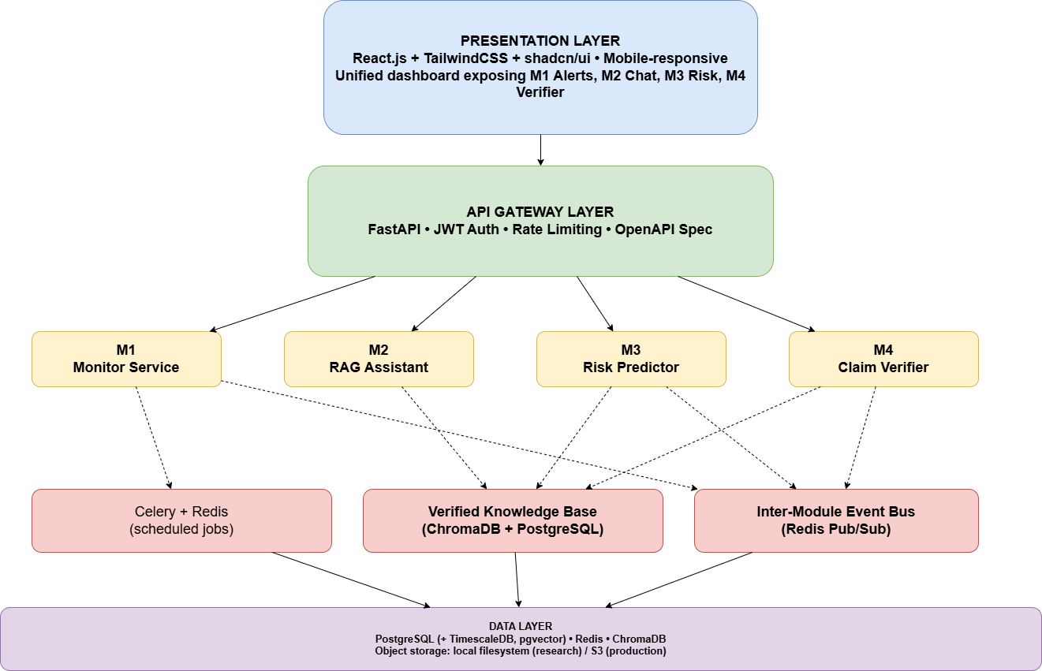
What the diagram shows. Identical to Figure 3 of the group report — the four-layer platform architecture: Presentation (React + Tailwind + shadcn/ui, unified dashboard for M1 Alerts, M2 Chat, M3 Risk, M4 Verifier), API Gateway (FastAPI, JWT auth, rate limiting, OpenAPI), the four module services (M1 Monitor, M2 RAG Assistant, M3 Risk Predictor, M4 Claim Verifier), shared services (Celery + Redis, Verified Knowledge Base on ChromaDB + PostgreSQL, Redis Pub/Sub event bus) and the data layer (PostgreSQL with TimescaleDB and pgvector, Redis, ChromaDB, object storage).
Figure 5.1 — Four-layer high-level architecture of the Enigmatrix platform
The presentation layer is a single application rendering all four modules through a unified dashboard, so that the SME sees one product rather than four tools. The API gateway layer terminates authentication, role-based authorisation and rate limiting, and routes to module services. Each module is a separately deployable service; in the research prototype they share a process, but the boundaries are drawn so that they could be scaled independently. Three shared infrastructure components bind the modules: Celery for scheduled jobs, the verified knowledge base for ground truth, and the event bus for cross-module triggers. The data layer consolidates relational, vector and cache storage.
The layered view in Figure 5.1 is realised concretely as follows.
Mermaid source (renderable at https://mermaid.live) — the authoritative, version-controlled form of this diagram:
flowchart TB
subgraph Presentation
FE["Next.js 14 App Router<br/>next-intl EN / SI / TA<br/>SME dashboard + admin console"]
end
subgraph API["API layer - FastAPI"]
AUTH["Auth + RBAC<br/>JWT, audit log"]
M1API["M1 routes<br/>regulations, extraction, datasets,<br/>measurements, alerts"]
MOD["M2 / M3 / M4 routes"]
end
subgraph Tasks["Async layer - Celery + Beat + Redis"]
SCR["run_scraper / gazette_scraper"]
EXT["extract_gazette"]
PRE["preprocess_gazette"]
CLS["classify_gazette"]
ALR["dispatch_regulation_alerts"]
WCH["portal_watcher / rss_watcher"]
ANA["refresh_lag_analytics / run_retraining"]
end
subgraph ML["enigmatrix-ml (package m1)"]
MEX["extraction/"]
MPR["preprocessing/"]
MMO["model/ - XLM-R + LoRA, ONNX"]
MEV["evaluation/ - measurement engine"]
end
subgraph Store["Storage"]
PG[("PostgreSQL<br/>m1_* tables + materialised views")]
CH[("ChromaDB")]
OBJ[("storage/ - PDFs, models")]
end
FE <--> AUTH
FE <--> M1API
FE <--> MOD
M1API --> Tasks
SCR --> EXT --> PRE --> CLS --> ALR
EXT --> MEX
PRE --> MPR
CLS --> MMO
M1API --> MEV
Tasks --> PG
Tasks --> OBJ
MOD --> CH
WCH --> PG
ANA --> PG
Placeholder in the Word original: a grey box awaiting the exported PNG of the Mermaid diagram above.
Figure 5.2 — Deployment-level component view of the implemented platform

5.2.1 Data flow design
The platform’s data flow is presented at two levels. The Level 0 context diagram shows the platform as a single process exchanging data with external actors; the Level 1 diagram decomposes it into the four modules with the verified knowledge base and the event bus as shared stores.
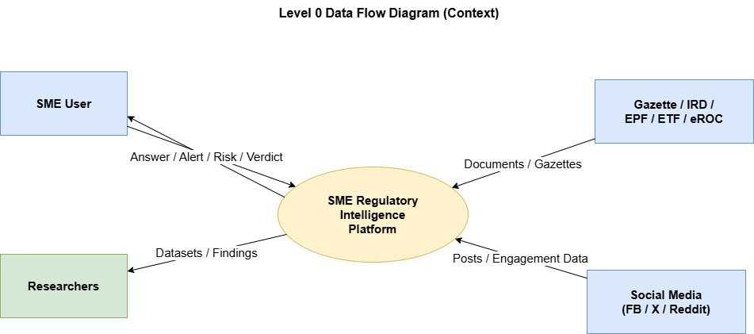
What the diagram shows. Level 0 context diagram — the SME Regulatory Intelligence Platform between four external entities: Gazette/IRD/EPF/ETF/eROC (documents in), Social Media FB/X/Reddit (posts and engagement data in), the SME User (answers, alerts, risk, verdicts out) and Researchers (datasets and findings out).
Figure 5.3 — Level 0 (context) data flow diagram
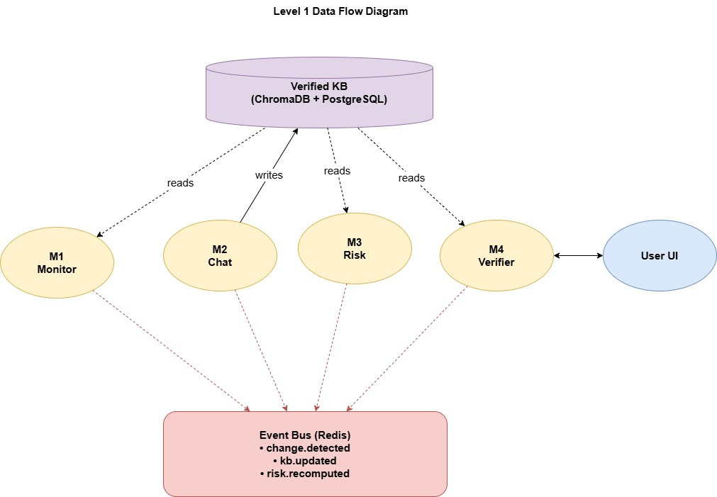
What the diagram shows. Level 1 data flow — the Verified KB (ChromaDB + PostgreSQL) with M2 Chat writing and M1 Monitor, M3 Risk and M4 Verifier reading; M4 exchanges with the User UI; all four publish change.detected, kb.updated and risk.recomputed onto the Redis event bus.
Figure 5.4 — Level 1 data flow diagram

5.2.2 Domain model
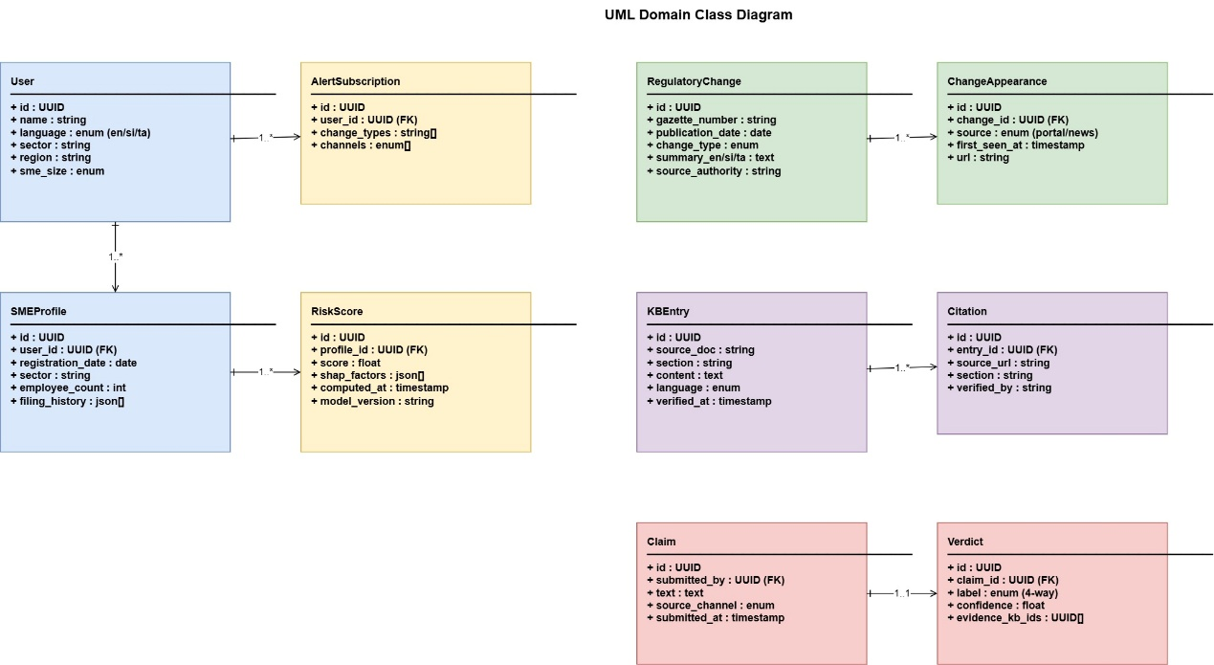
What the diagram shows. The UML domain class diagram — User → AlertSubscription and SMEProfile → RiskScore; RegulatoryChange → ChangeAppearance; KBEntry → Citation; Claim → Verdict — with the same attributes and multiplicities as Figure 7 of the group report.
Figure 5.5 — Domain class diagram

5.2.3 Representative interaction
The most representative cross-module interaction is a user submitting a compliance question, with a parallel risk recomputation triggered by an inbound regulatory change.
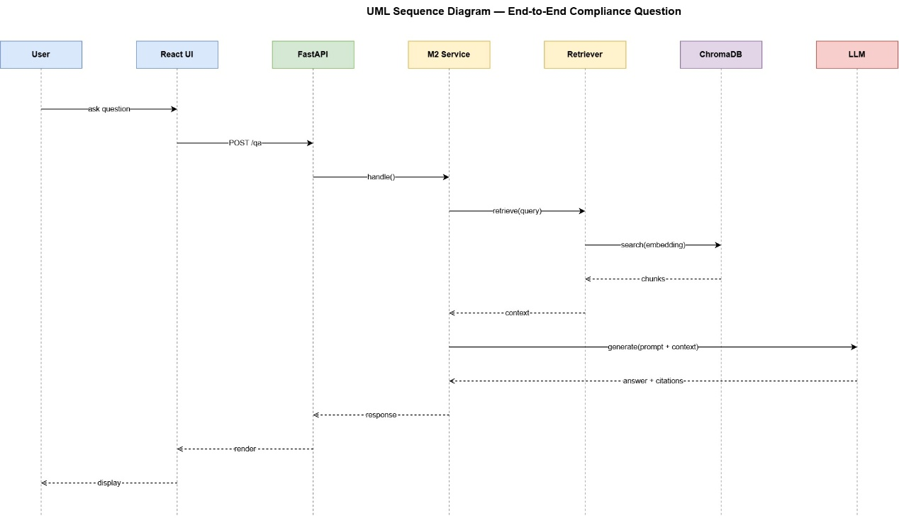
What the diagram shows. The UML sequence diagram for an end-to-end compliance question across User, React UI, FastAPI, M2 Service, Retriever, ChromaDB and LLM — ask question → POST /qa → handle() → retrieve(query) → search(embedding) → chunks → context → generate(prompt + context) → answer + citations → response → render → display.
Figure 5.6 — Sequence diagram for an end-to-end compliance question

5.2.4 Database design
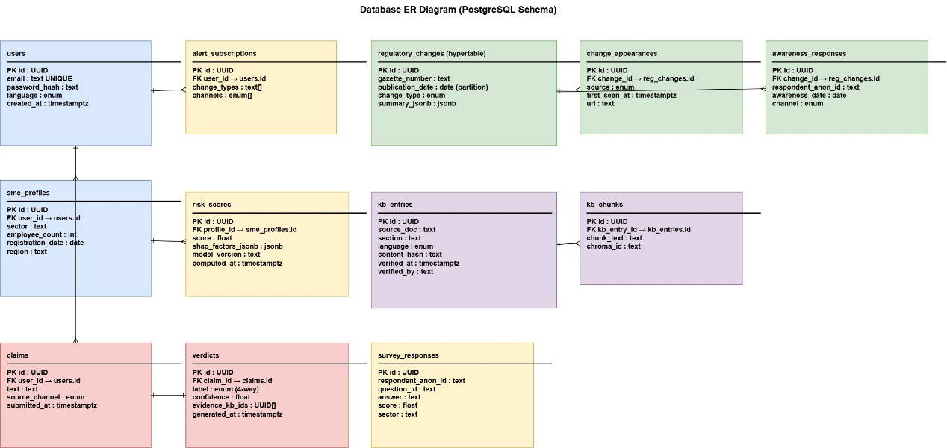
What the diagram shows. The PostgreSQL ER design for the shared database — users, alert_subscriptions, regulatory_changes (hypertable partitioned on publication_date), change_appearances, awareness_responses, sme_profiles, risk_scores, kb_entries, kb_chunks, claims, verdicts and survey_responses, with primary and foreign keys annotated on each entity.
Figure 5.7 — Entity relationship design of the shared database
The implemented Module 1 schema is summarised below. Platform tables shared with the other modules include users, sme_profiles, audit_log, the survey_* family, sectors and regulatory_domains.
Table 5.1 — Principal Module 1 database objects
Object | Purpose
m1_regulations | Core record with the status machine, extraction and classifier columns
m1_regulation_sectors | Many-to-many regulation ↔ sector relevance
m1_regulation_penalties | Extracted penalty structures, including the multi-penalty case
m1_sub_documents | Independent instruments split from a single gazette issue
m1_gazette_items | Item-level index of a gazette issue
m1_extraction_profiles / m1_extraction_runs | Versioned extractor configurations and their executions
m1_datasets / m1_dataset_versions / m1_dataset_rows | Dataset registry with immutable sealed versions and SHA-256 content hashes
m1_measurement_runs / m1_measurement_scores | Measurement executions and per-field scores
m1_propagation_events | Diffusion observations, unique on (regulation, source), with first_seen_at
m1_alerts | Dispatched alerts; sme_id IS NULL denotes a public broadcast
m1_retraining_runs | Retraining executions and promotion decisions
v_m1_regulation_lag_summary, v_m1_channel_effectiveness | Materialised views refreshed nightly for lag analytics

5.3 High-Level Architectures of Individual Modules

5.3.1 Module 1 — Regulatory Change Awareness Gap
Module 1 is structured as a five-stage Celery pipeline with a parallel measurement loop, as designed at interim stage and implemented since.
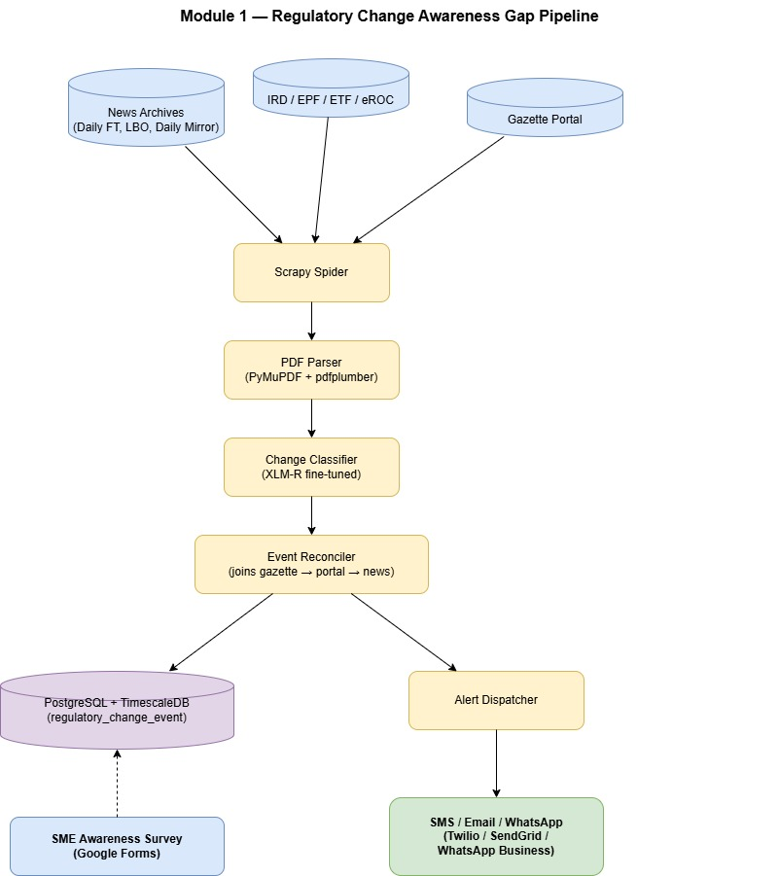
What the diagram shows. The Module 1 pipeline — News Archives, IRD/EPF/ETF/eROC and the Gazette Portal → Scrapy Spider → PDF Parser (PyMuPDF + pdfplumber) → Change Classifier (fine-tuned XLM-R) → Event Reconciler (joins gazette → portal → news) → PostgreSQL + TimescaleDB (regulatory_change_event) and Alert Dispatcher → SMS / Email / WhatsApp, with the SME Awareness Survey (Google Forms) feeding the database.
Figure 5.8 — Module 1 pipeline design
The regulation status machine. Every record advances through a strict status machine. Status is a first-class evaluated field: a record that should have reached classified but stopped at preprocessed is a stage-progression failure, tracked separately from field accuracy.
Table 5.2 — Regulation status machine and the fields introduced at each stage
Status | Entered by | Fields introduced
ingested | Scrapy spider | m1_gazette_items, raw_pdf_path, gazette_number, document_number, source_url
extracted | extract_gazette | raw_text, extraction_method, extracted_at, file_size_bytes, sha256, pdf_pages, language
preprocessed | preprocess_gazette | cleaned_text, classification_chunk, amendment_type, metadata_confidence, m1_sub_documents, m1_regulation_penalties
classified | classify_gazette | domain_code, change_category, severity_level, is_sme_relevant, classifier_confidence, classified_at
Mermaid source (renderable at https://mermaid.live) — the authoritative, version-controlled form of this diagram:
stateDiagram-v2
[*] --> ingested: Scrapy spider (date-scoped, EN to SI to TA fallback)
ingested --> extracted: extract_gazette<br/>classify_pdf then text / hybrid / scanned route
extracted --> preprocessed: preprocess_gazette<br/>clean, fastText LID, Wijesekara, metadata, chunk
preprocessed --> classified: classify_gazette<br/>ONNX XLM-R + LoRA
classified --> alerted: dispatch_regulation_alerts<br/>sector-matched, idempotent
preprocessed --> review: metadata_confidence below threshold
classified --> review: decision_margin < 0.40 (provisional; was classifier_confidence < 0.55)
review --> classified: expert verification (never overwritten)
alerted --> [*]
Placeholder in the Word original: a grey box awaiting the exported PNG of the Mermaid diagram above.
Figure 5.9 — Regulation status machine with review routing
Extraction design. Engine choice must be made per page, not per document. classify_pdf inspects text yield and image coverage and assigns one of three routes; within the hybrid route each page is dispatched individually. Extraction profiles are registered entities, so a measurement result is always attributable to a named, versioned configuration.
Mermaid source (renderable at https://mermaid.live) — the authoritative, version-controlled form of this diagram:
flowchart TD
PDF["Raw gazette PDF"] --> CLF["classify_pdf<br/>text yield + image coverage thresholds"]
CLF -->|text| T1["PyMuPDF TEXTFLAGS_TEXT"]
T1 --> T2["pdfplumber<br/>layout + tables"]
CLF -->|hybrid| H1["Per-page routing"]
H1 --> T1
H1 --> S1
CLF -->|scanned| S1["Tesseract 5<br/>--oem 1 --psm 6 -l eng+sin+tam @300dpi"]
S1 -->|low confidence| S2["Surya OCR fallback profile"]
T2 --> FONT["Font inspection"]
S1 --> FONT
S2 --> FONT
FONT -->|legacy font detected| WJ["Wijesekara to Unicode conversion"]
FONT -->|Unicode| RAW["raw_text"]
WJ --> RAW
RAW --> CER["CER / WER calculator<br/>vs sealed ground truth"]
RAW --> SEG["Segmenter<br/>sub-document splitting"]
Placeholder in the Word original: a grey box awaiting the exported PNG of the Mermaid diagram above.
Figure 5.10 — Extraction and OCR routing chain
Classification design. The classifier is a single XLM-RoBERTa encoder with LoRA adapters and two output heads.
Mermaid source (renderable at https://mermaid.live) — the authoritative, version-controlled form of this diagram:
flowchart LR
IN["classification_chunk<br/>max 512 tokens, EN / SI / TA"] --> TOK["XLM-R SentencePiece tokenizer"]
TOK --> ENC["XLM-RoBERTa base encoder<br/>frozen weights"]
ENC --> LORA["LoRA adapters<br/>r, alpha=32, dropout=0.1<br/>targets: query, value"]
LORA --> POOL["CLS-pooled representation + dropout"]
POOL --> H1["Category head<br/>8 classes, softmax"]
POOL --> H2["Sector head<br/>3 labels, sigmoid"]
H1 --> L1["Cross-entropy loss"]
H2 --> L2["Binary cross-entropy loss"]
L1 --> TOT["Total loss = CE + w * BCE"]
L2 --> TOT
H1 --> OUT1["change_category + classifier_confidence"]
H2 --> OUT2["affected_sectors"]
OUT1 --> GATE{"SUPERSEDED: confidence >= 0.55 ?<br/>as built: decision_margin >= 0.40"}
GATE -->|yes| ACCEPT["status = classified"]
GATE -->|no| REVIEW["route to expert review"]
Placeholder in the Word original: a grey box awaiting the exported PNG of the Mermaid diagram above.
Figure 5.11 — XLM-RoBERTa with LoRA adapters and a dual classification head
Table 5.3 — Classification design decisions and their rationale
Decision | Rationale
Single multilingual encoder | Labelled data per language is scarce; cross-lingual transfer is worth more than per-language specialisation at this scale
LoRA rather than full fine-tuning | Reduces trainable parameters so a single free-tier GPU session suffices; base weights stay frozen and reusable
Dual head, not two models | Category and sector share the same textual evidence; joint training regularises both and halves the deployment surface
Softmax for category, sigmoid for sectors | Category is mutually exclusive by construction; a regulation may affect several sectors simultaneously
Confidence threshold 0.55 for review → decision-margin threshold 0.40, provisional [v2] | The frozen model emits no probability, so no calibrated threshold exists. 0.40 is a validation-derived candidate carried in .env.example; the live audit contains zero completed review outcomes, so it is explicitly provisional_no_review_outcomes
Expert-verified rows never overwritten | Human verification is authoritative; a later model run must not silently regress a checked record
ONNX with optional INT8 | Production hosting has no GPU; INT8 reduces latency and memory at a measured accuracy cost
Propagation, alerting and analytics design. The measurement instrument is a two-step matcher that links content observed on secondary channels back to the primary gazette record.
Mermaid source (renderable at https://mermaid.live) — the authoritative, version-controlled form of this diagram:
flowchart LR
SRC["Secondary sources<br/>IRD / EPF / ETF / eROC portals<br/>+ 5 news RSS feeds"] --> W["portal_watcher / rss_watcher<br/>Celery Beat, every 2 h"]
W --> M1{"Exact gazette-number match?"}
M1 -->|yes, confidence 1.0| EV["m1_propagation_events<br/>unique (regulation, source)<br/>first_seen_at"]
M1 -->|no| M2{"difflib title similarity >= 0.78 ?"}
M2 -->|yes| EV
M2 -->|no| DROP["Discard - no match"]
EV --> MV["Materialised views<br/>v_m1_regulation_lag_summary<br/>v_m1_channel_effectiveness"]
MV --> NB["Findings notebooks F1-F6"]
REG["Classified regulation"] --> AL["dispatch_regulation_alerts<br/>idempotent, unique regulation x recipient x channel"]
SMEP["SME profiles<br/>sector match"] --> AL
AL --> CH["In-app + SendGrid email + Twilio SMS<br/>sme_id NULL = public broadcast"]
CH --> NB
Placeholder in the Word original: a grey box awaiting the exported PNG of the Mermaid diagram above.
Figure 5.12 — Propagation measurement and alert dispatch design
Alert dispatch is idempotent and keyed uniquely on (regulation, recipient, channel). A re-run must never double-send, both because duplicate notifications destroy user trust and because a duplicated alert would corrupt the difference-in-differences analysis of alert effectiveness.

5.3.2 Module 2 — Compliance Knowledge Accuracy Gap
[M2 PLACEHOLDER] — to be completed by the responsible member. The interim design is reproduced below as the starting point and should be replaced with the implemented architecture.
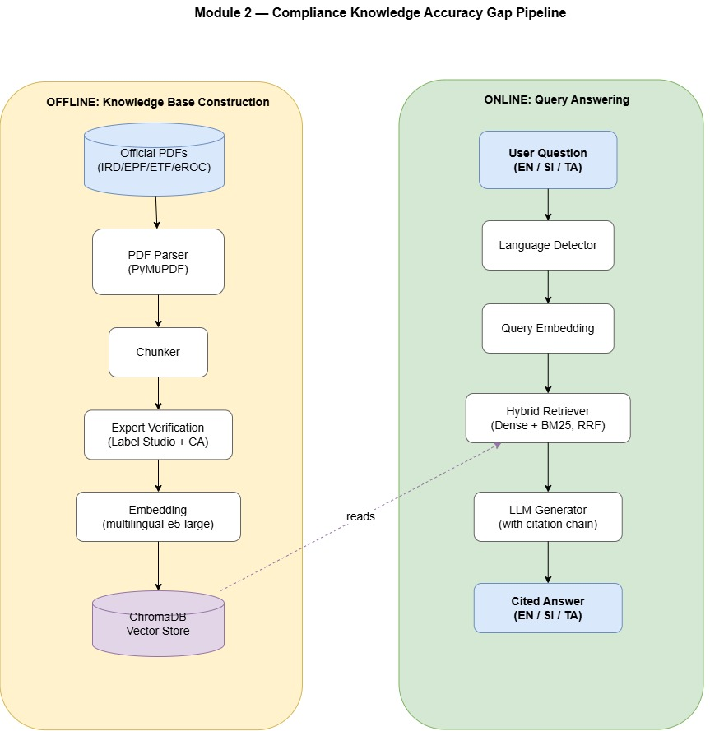
What the diagram shows. Module 2 split into two enclosures. OFFLINE: Knowledge Base Construction — Official PDFs (IRD/EPF/ETF/eROC) → PDF Parser (PyMuPDF) → Chunker → Expert Verification (Label Studio + CA) → Embedding (multilingual-e5-large) → ChromaDB Vector Store. ONLINE: Query Answering — User Question (EN/SI/TA) → Language Detector → Query Embedding → Hybrid Retriever (Dense + BM25, RRF) → LLM Generator (with citation chain) → Cited Answer (EN/SI/TA). A dashed reads edge links the ChromaDB store to the hybrid retriever.
Figure 5.13 — Module 2 pipeline design (interim)

5.3.3 Module 3 — Compliance Risk Invisibility Gap
[M3 PLACEHOLDER] — to be completed by the responsible member.
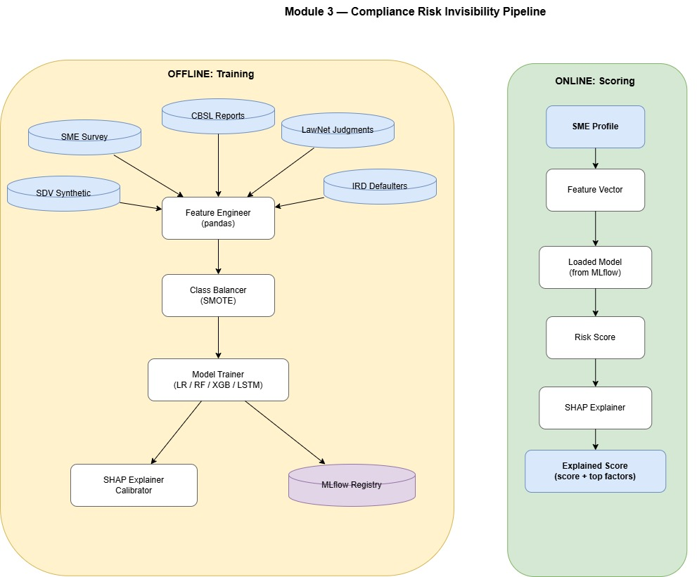
What the diagram shows. Module 3 split into two enclosures. OFFLINE: Training — five sources (SME Survey, CBSL Reports, LawNet Judgments, IRD Defaulters, SDV Synthetic) → Feature Engineer (pandas) → Class Balancer (SMOTE) → Model Trainer (LR / RF / XGB / LSTM) → SHAP Explainer Calibrator and MLflow Registry. ONLINE: Scoring — SME Profile → Feature Vector → Loaded Model (from MLflow) → Risk Score → SHAP Explainer → Explained Score (score + top factors).
Figure 5.14 — Module 3 pipeline design (interim)

5.3.4 Module 4 — Regulatory Misinformation Spread Gap
[M4 PLACEHOLDER] — to be completed by the responsible member.
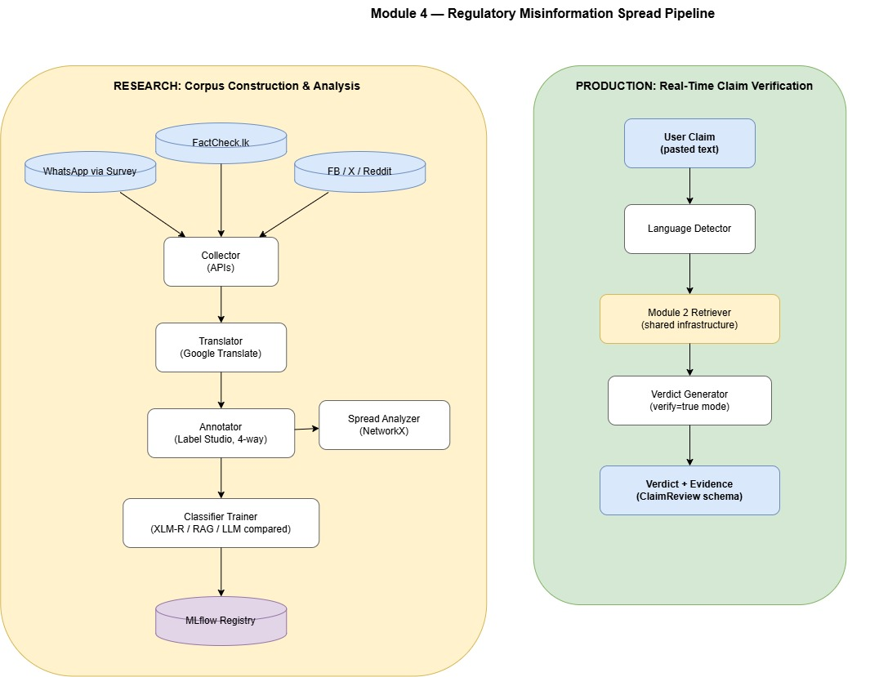
What the diagram shows. Module 4 split into two enclosures. RESEARCH: Corpus Construction & Analysis — WhatsApp via Survey, FactCheck.lk and FB/X/Reddit → Collector (APIs) → Translator (Google Translate) → Annotator (Label Studio, 4-way), which also feeds a Spread Analyzer (NetworkX) → Classifier Trainer (XLM-R / RAG / LLM compared) → MLflow Registry. PRODUCTION: Real-Time Claim Verification — User Claim (pasted text) → Language Detector → Module 2 Retriever (shared infrastructure) → Verdict Generator (verify=true mode) → Verdict + Evidence (ClaimReview schema).
Figure 5.15 — Module 4 pipeline design (interim)

5.4 Summary
The design separates three concerns that are frequently conflated: the operational pipeline that produces regulatory intelligence, the measurement framework that quantifies how well it does so, and the research instrument that observes how that intelligence propagates. Each has its own tables, its own metrics and its own failure modes. That separation is what allows Chapter 7 to report extraction accuracy, model accuracy and diffusion lag as independent, individually defensible results.

Chapter 6 - Implementation

6.1 Introduction
This chapter documents how the design of Chapter 5 was realised. Section 6.2 describes data collection, including the construction of the private labelled dataset that is the empirical foundation of Module 1. Section 6.3 documents the implementation of each module, with the principal source files named so that every claim can be verified against the repository, and with representative code listings and interface captures.

6.2 Data Collection
Three distinct datasets were collected: a raw document corpus, a private labelled gold dataset, and a sealed evaluation baseline.
Table 6.1 — Datasets used in this project
Dataset | Size | Provenance | Role
Raw gazette corpus | 800 PDFs across 11 extraction batches | gazette.lk, documents.gov.lk | Source material for extraction and preprocessing
Gold labelled dataset v1 | 800 reconciled records | Dual annotation in Label Studio, adjudicated | Training, validation and test data for classification
Sealed evaluation baseline | ~800 curated field-level rows (Jan–Apr 2026) | Manually curated workbook, SHA-256 checksummed | Ground truth for extraction and stage accuracy
Database regression snapshot | ~204 rows, most at preprocessed | Production database export, February 2026 | Stage-progression and regression tracking
Calibration set | 20 trilingual documents with expert labels and rationales | Domain expert | Annotator alignment before production labelling

6.2.1 Document collection
Four Scrapy spiders — gazette_spider, weekly_gazette_spider, acts_spider and bills_spider — collect from the two official sources. Each supports date scoping and closes on scope exhaustion, falls back English→Sinhala→Tamil when an edition is missing, and exposes completeness verification and re-fetch endpoints so gaps are detected rather than silently tolerated. Collection is scheduled every six hours through Celery Beat and can also be triggered for a specific date range from the admin console.
Principal files: enigmatrix-backend/scraper/spiders/*.py, app/tasks/m1/run_scraper.py, app/tasks/m1/gazette_scraper.py, app/api/v1/m1_completeness.py.

6.2.2 Annotation and gold dataset construction
No labelled dataset of Sri Lankan regulatory changes exists, so one was created. The protocol was designed so that the result would be defensible as ground truth.
- Calibration. A 20-document trilingual calibration set with expert labels and written rationales was completed by every annotator before production labelling. Calibration disagreements were discussed and the decision hints in the guideline were refined.
- Sampling. Documents were drawn using stratified and k-means samplers with explicit minority-domain targeting, plus a hybrid active-learning mode, so annotation effort concentrated where it changes the model rather than on whatever arrived first.
- Dual annotation. Batches 02–05 were labelled independently by two annotators. Each task captured change category, affected sectors, SME relevance, an annotator confidence rating and free-text notes.
- Automated reduction. scripts/resolve_iaa.py paired annotations, computed agreement statistics and emitted agreed rows directly to gold.
- Manual adjudication. The 40 disagreement rows were adjudicated by a resolver and recorded in manual_resolutions.csv with a resolution method and resolver identifier. The final gold file contains zero lead-annotator fallback rows — every disagreement was decided explicitly, not defaulted.
- Freezing. The result was frozen as gold_standard_v1_800.csv with an accompanying iaa_report_v1_800.json.
[ SCREENSHOT PLACEHOLDER — image not yet inserted in the Word original ] Label Studio annotation interface showing a gazette chunk with the 8-domain / 3-sector / SME-relevance / confidence labelling schema. Capture from the Label Studio project defined by research/data/label_studio_config.xml
Figure 6.1 — Label Studio annotation interface for the Module 1 labelling schema
The label schema is defined once in code and mirrored into the Label Studio configuration and the database enumerations.
Listing 6.1 — Canonical label schema (enigmatrix-ml/m1/model/labels.py)
CATEGORIES: list[str] = [
"TAX_RATE_CHANGE", "IMPORT_EXPORT", "SECTOR_SPECIFIC", "EPF_ETF_CHANGE",
"LABOUR_LAW", "PRODUCT_STANDARD", "BUSINESS_REGISTRATION",
"PENALTY_ENFORCEMENT",
]
SECTORS: list[str] = [
"grocery_retail", "food_service", "general_retail",
]
CAT_TO_ID: dict[str, int] = {c: i for i, c in enumerate(CATEGORIES)}
ID_TO_CAT: dict[int, str] = {i: c for c, i in CAT_TO_ID.items()}
SECTOR_TO_ID: dict[str, int] = {s: i for i, s in enumerate(SECTORS)}
def encode_sectors(value) -> list[int]:
"""Multi-hot vector of length len(SECTORS)."""
vec = [0] * len(SECTORS)
for s in parse_sectors(value):
vec[SECTOR_TO_ID[s]] = 1
return vec
The three study sectors were selected because they are numerous among Sri Lankan SMEs, are affected by all eight categories, and are distinguishable by an annotator without specialist domain training. Restricting scope to three sectors is a deliberate trade-off: it keeps annotation feasible at the required agreement level, at the cost of limiting immediate generalisation. This is stated as a limitation in Chapter 8 rather than concealed.
Table 6.2 — Columns of the frozen gold dataset
Group | Columns
Identity | batch_id, regulation_id, regulation_key, gazette_number, year, language
Model input | classification_chunk
Labels | change_category, affected_sectors, is_sme_relevant
Annotator signal | confidence, confidence_mean, annotator_ids, annotator_notes
Adjudication provenance | resolution_method, resolver_id, disagreement_fields, resolver_notes, source_exports

6.3 Implementation of Individual Modules

6.3.1 Module 1 — Regulatory Change Awareness Gap
Module 1 was implemented in five phases. All five are complete in code; the human and data gates that remain are stated explicitly in Chapter 7.

6.3.1.1 Phase 1 — Platform foundation
JWT authentication (bcrypt hashing, HS256 access and refresh tokens) with role-based access control across sme, admin and annotator roles; slowapi rate limiting; audit logging on every authentication event and administrative mutation; regulation CRUD at /admin/regulations with soft deletion via is_active, an expert-verification gate, bulk verification and restore; sector mapping and seed data.
Principal files: app/api/v1/m1_regulations.py, app/services/m1_regulation_service.py, app/models/regulation.py.

6.3.1.2 Phase 2 — Ingestion, extraction, preprocessing and measurement
This is the largest completed block. The canonical extraction implementation lives in enigmatrix-ml/m1/extraction/; the backend app/extraction/ is a thin re-export adapter that preserved existing imports and tests while removing roughly ninety lines of duplicated logic. Components: the classify_pdf router; per-page engines (PyMuPDF, pdfplumber, pypdfium2, Tesseract, Surya); registered profiles legacy_v1, page_routing_v1, surya_fallback_v1 and wijesekara_routing_v1; a font-aware Wijesekara-to-Unicode converter; a CER calculator; and a segmenter. Preprocessing (enigmatrix-ml/m1/preprocessing/) performs cleaning, fastText language identification, metadata and penalty extraction, chunking and sub-document splitting.
The operational console at /admin/m1/pipeline streams live progress over a WebSocket at /ws/extraction/{task_id} and provides a date-range picker, run history, cancel and rollback, a PDF Records page and a per-regulation pipeline trace.
[ SCREENSHOT PLACEHOLDER — image not yet inserted in the Word original ] Admin pipeline console at /admin/m1/pipeline showing the funnel by status, a date-scoped extraction run in progress and live WebSocket progress.
Figure 6.2 — Administrative extraction pipeline console
Principal files: app/api/v1/m1_gazette_extraction.py (17 routes), app/api/v1/m1_extraction_ws.py.

6.3.1.3 Phase 2 — Extraction accuracy measurement subsystem
This subsystem answers the question “how good is our extraction?” quantitatively and is a core artefact of the dissertation.
- Dataset registry — m1_datasets, m1_dataset_versions, m1_dataset_rows: named datasets with immutable sealed versions carrying SHA-256 content hashes, Excel ground-truth upload, retire and restore, and a nightly retention policy that keeps the current version, the previous version and anything flagged keep.
- Extraction profile registry and run dispatcher — runs any profile against a defined scope, with overlap detection and automatic v1→v2 versioning when a new run’s date range overlaps an existing version.
- Measurement engine (enigmatrix-ml/m1/evaluation/) — per-field comparators for categorical, date, numeric, string, semantic and text-summary types; aggregates; strata; raw-text scoring; completeness; and a date-scope filter so that a date-scoped run is not penalised against the full ground truth.
- Measurement UI at /admin/datasets/m1/measurements* — run form with optional date-range and source scoping, dashboard, per-run detail, per-regulation drill-down, worst-N view, calibration view, sortable columns, sparklines and keyboard shortcuts.
- Accuracy report export — GET /api/v1/m1/measurements/{run_id}/report.md returns a downloadable Markdown report produced by a pure function in m1_measurement_report.py.
- Data-quality suites — Great-Expectations-style JSON expectations in data_quality/expectations/ validated automatically after sealing by the validate_dataset_version task.
- Thesis artefact generator — scripts/regenerate_thesis_tables.py, invoked by make thesis-artifacts. > [ SCREENSHOT PLACEHOLDER — image not yet inserted in the Word original ] Measurement dashboard at /admin/datasets/m1/measurements showing overall micro/macro/weighted scores, the per-field leaderboard and the worst-N drill-down.
Figure 6.3 — Extraction accuracy measurement dashboard

6.3.1.4 Phase 3 — Annotation, dataset preparation and classification
Dataset preparation is implemented in m1.model.data, which produces train/validation/test Parquet splits either deterministically on regulation_key or temporally on gazette_published_date. TF-IDF baselines are implemented in m1.model.baselines.
The classifier itself is a single encoder with two heads.
Listing 6.2 — Model architecture (enigmatrix-ml/m1/model/architecture.py)
class GazetteClassifier(nn.Module):
"""CLS-pooled XLM-R (LoRA-adapted) -> single-label category head +
multi-label sector head. Head widths come from ModelConfig."""
def __init__(self, cfg: ModelConfig | None = None):
super().__init__()
self.cfg = cfg or ModelConfig()
encoder = AutoModel.from_pretrained(self.cfg.base_model)
self.encoder = get_peft_model(encoder, LoraConfig(
r=self.cfg.lora_r, lora_alpha=self.cfg.lora_alpha,
lora_dropout=self.cfg.lora_dropout,
target_modules=list(self.cfg.lora_targets), bias="none",
task_type="FEATURE_EXTRACTION",
))
hidden = encoder.config.hidden_size
self.dropout = nn.Dropout(0.1)
self.category_head = nn.Linear(hidden, self.cfg.num_categories)
self.sector_head = nn.Linear(hidden, self.cfg.num_sectors)
def forward(self, input_ids, attention_mask):
out = self.encoder(input_ids=input_ids, attention_mask=attention_mask)
pooled = self.dropout(out.last_hidden_state[:, 0]) # [CLS]
return self.category_head(pooled), self.sector_head(pooled)
def compute_loss(category_logits, sector_logits, category_target,
sector_target=None, sector_weight: float = 1.0,
class_weights=None):
"""CrossEntropy on the category head + BCE on the multi-label sector head."""
ce = nn.functional.cross_entropy(category_logits, category_target,
weight=class_weights)
if sector_target is None:
return ce
bce = nn.functional.binary_cross_entropy_with_logits(
sector_logits, sector_target.float())
return ce + sector_weight * bce
Training hyper-parameters are held in a single dataclass so that every run is fully described by one serialisable object, which is written into the model registry alongside the metrics.
Listing 6.3 — Training configuration (enigmatrix-ml/m1/model/config.py)
@dataclass
class ModelConfig:
base_model: str = "xlm-roberta-base"
num_categories: int = len(CATEGORIES) # 8
num_sectors: int = len(SECTORS) # 3
max_length: int = 512
# LoRA
lora_r: int = 16
lora_alpha: int = 32
lora_dropout: float = 0.1
lora_targets: tuple[str, ...] = ("query", "value")
# optimisation
lr_head: float = 2e-5
lr_lora: float = 1e-4
weight_decay: float = 0.01
warmup_ratio: float = 0.1
epochs: int = 8
batch_size: int = 16
early_stop_patience: int = 3
fp16: bool = True
sector_loss_weight: float = 1.0
seeds: tuple[int, ...] = (42, 1, 2)
Two learning rates are used deliberately: the randomly initialised classification heads take the higher rate (1e-4 is applied to the LoRA parameters, 2e-5 to the head), warmup is applied over the first 10 % of steps, and early stopping with patience 3 guards against overfitting on a small dataset.
Evaluation and export. m1/model/eval.py computes per-slice macro-F1 by language, quarter and text length, applies the 8-percentage-point slice-cliff check and writes an error-analysis CSV. m1/model/export_onnx.py merges the LoRA weights into the base model and exports to ONNX with optional INT8 quantisation.
Production inference ⟦v2 — corrected⟧. classifier_service.py is a two-backend service selected by M1_CLASSIFIER_BACKEND, default linearsvc. On the default path LinearSVCGazetteInference loads models/m1/linearsvc_v6_primary/linearsvc_pipeline.joblib and returns confidence: null with a decision_margin. The ONNX path described below is dormant: M1_MODEL_ONNX_DIR (default storage/models/m1/onnx/v1) is empty — no ONNX artefact was ever exported. Migration 202608010001 added classifier_decision_margin and classifier_model_name and is applied live. When the directory is absent or empty, classifier_status() returns no_model and classify_gazette_task leaves the record at preprocessed — the correct and safe behaviour before a model is promoted. Migration 202606300001 adds the classifier confidence columns.

6.3.1.5 Model training on free GPU platforms
Training is executed on Google Colab and Kaggle Notebooks. The command is identical on both; only the environment preparation differs.
# Colab / Kaggle setup cell
pip install uv
cd /content/xyz/enigmatrix-ml # Kaggle: /kaggle/working/xyz/enigmatrix-ml
uv sync --extra training --extra research
# three-seed training run
uv run python -m m1.model.train_xlmr \
--data datasets/m1_regulations \
--seeds 42 1 2 \
--base xlm-roberta-base \
--lora-r 16 --epochs 8 --fp16 \
--out ../storage/models/m1/xlmr_lora_v1
# per-slice evaluation and ONNX export
uv run python -m m1.model.eval \
--model ../storage/models/m1/xlmr_lora_v1 \
--test datasets/m1_regulations/test.parquet \
--report ../storage/models/m1/eval_v1
uv run python -m m1.model.export_onnx \
--model ../storage/models/m1/xlmr_lora_v1 \
--out ../storage/models/m1/onnx/v1 --int8
[ SCREENSHOT PLACEHOLDER — image not yet inserted in the Word original ] Kaggle Notebook (or Google Colab) session showing the GPU accelerator enabled, the training cell running, and the per-epoch validation macro-F1 output for the three-seed XLM-R + LoRA run.
Figure 6.4 — GPU training session on the free notebook platform
On Kaggle the frozen gold dataset and the generated Parquet splits are attached as a versioned Kaggle Dataset, which pins the exact data a run consumed; on Colab the repository is cloned or Google Drive is mounted. Both paths write the same model_registry.json, so the two platforms produce directly comparable artefacts.

6.3.1.6 Phase 4 — Watchers, alerts and analytics
- Propagation. m1_propagation_events with a uniqueness constraint on (regulation, source) and a first_seen_at timestamp; a secondary-source registry covering the IRD, EPF, ETF and eROC portals plus five news RSS feeds; a two-step matcher (exact gazette-number match at confidence 1.0, then difflib similarity ≥ 0.78), unit-tested; portal_watcher and rss_watcher on a two-hourly offset Beat schedule.
- Alerts. m1_alerts with a uniqueness constraint on (regulation, recipient, channel) and sme_id IS NULL denoting a public broadcast; a pure alert-content builder; SendGrid and Twilio providers that degrade gracefully to a skipped status without API keys; an idempotent alert service; a batched dispatch task; API routes /m1/alerts/public, /m1/alerts and mark-read; and the frontend /alerts page.
- Analytics. Materialised views v_m1_regulation_lag_summary and v_m1_channel_effectiveness; a Kullback–Leibler confidence-drift helper alerting above 0.15; nightly refresh_lag_analytics. > [ SCREENSHOT PLACEHOLDER — image not yet inserted in the Word original ] Public and sector-matched alert feed at /alerts, showing a classified regulation with its category badge, affected sectors and plain-language summary.
Figure 6.5 — SME-facing regulatory alert feed

6.3.1.7 Phase 5 — Findings and retraining
The diffusion analysis is preregistered in enigmatrix-ml/research/preregistration.md at α = 0.05 with bootstrap confidence intervals, fixing hypotheses F1–F6 before the data is unblinded. findings_common.py provides tested loaders and bootstrap CI computation with a database-or-synthetic-demo mode, and four notebooks cover lag analysis, secondary diffusion, alert effectiveness by difference-in-differences, and classifier evaluation.
Retraining is recorded in m1_retraining_runs and gated by a pure, unit-tested decision function.
Listing 6.4 — Canary promotion decision (enigmatrix-ml/m1/model/promotion.py)
def decide(prod_f1, candidate_f1, gate: float = 0.92, regression_tol: float = 0.01):
"""Return (action, reason) where action in {promote, rollback, hold}."""
if candidate_f1 is None:
return ("hold", "no candidate metric")
if candidate_f1 < gate:
return ("rollback", f"candidate {candidate_f1:.3f} below gate {gate:.2f}")
if prod_f1 is not None and candidate_f1 < prod_f1 - regression_tol:
return ("rollback",
f"candidate {candidate_f1:.3f} regresses vs prod {prod_f1:.3f}")
return ("promote", f"candidate {candidate_f1:.3f} clears gate {gate:.2f}")
Keeping this function free of framework and database dependencies is what makes the promotion policy exhaustively testable — the decision that governs whether a model reaches users is the one component that must not be able to fail silently.

6.3.1.8 Summarisation and translation
Implemented components: database, model and schema fields for title_en, title_si, title_ta, summary_en, summary_si and summary_ta; an administrative translation queue at app/api/v1/admin_translations.py; an NLLB-200 helper at scripts/lib/nllb_translate.py; a gazette title scraper at scripts/lib/title_scraper.py; and field-metric support for title and summary fields in the measurement tooling.
Mermaid source (renderable at https://mermaid.live) — the authoritative, version-controlled form of this diagram:
flowchart LR
A["Extracted + cleaned regulation text"] --> B["Classification<br/>change_category + affected_sectors"]
B --> C["Controlled English summary generation<br/>inputs: title, domain, sectors,<br/>amendment type, cleaned text"]
C --> D["summary_en"]
T["title_en<br/>from gazette or title scraper"] --> E
D --> E["NLLB-200 distilled 600M<br/>Colab / Kaggle GPU"]
E --> F["title_si, title_ta<br/>summary_si, summary_ta"]
F --> G{"Quality check<br/>length, script, empty, truncation"}
G -->|pass| H["Publish to SME alerts + dashboard<br/>in user's preferred language"]
G -->|fail| I["Admin translation review queue"]
I --> H
Placeholder in the Word original: a grey box awaiting the exported PNG of the Mermaid diagram above.
Figure 6.6 — Summarisation and Sinhala/Tamil translation flow
[ SCREENSHOT PLACEHOLDER — image not yet inserted in the Word original ] Administrative translation review queue showing an English title and summary alongside their machine-generated Sinhala and Tamil renderings, with approve / edit / reject controls.
Figure 6.7 — Administrative translation review queue
Status statement. The schema, the review queue, the NLLB helper and the title scraper are implemented. The production batch summary generator and the bulk translation backfill are the remaining pieces; Section 7.2.1 gives the commands to complete and evidence them, and this report does not claim large-scale automatic summarisation output that has not been produced.

6.3.1.9 Frontend
The SME-facing surface provides registration with a business profile, a trilingual dashboard, a regulation feed, the alerts page and the survey wizard. The administrative surface provides regulation CRUD and verification, the pipeline console, the dataset registry, the measurement dashboards and drill-downs, the translation queue, user management and the activity log. Localisation is handled by next-intl across English, Sinhala and Tamil with script-appropriate fonts.
[ SCREENSHOT PLACEHOLDER — image not yet inserted in the Word original ] SME dashboard rendered in Sinhala and in Tamil, side by side with the English view, showing the language selector and the sector-matched regulation feed.
Figure 6.8 — Trilingual SME dashboard

6.3.2 Module 2 — Compliance Knowledge Accuracy Gap
[M2 PLACEHOLDER] — to be completed by the responsible member: implementation details, key code decisions, interface captures.

6.3.3 Module 3 — Compliance Risk Invisibility Gap
[M3 PLACEHOLDER] — to be completed by the responsible member.

6.3.4 Module 4 — Regulatory Misinformation Spread Gap
[M4 PLACEHOLDER] — to be completed by the responsible member.

6.4 Summary
Module 1 is implemented across all five phases. Phases 1, 2, 4 and 5 are complete in code, with Phase 2 additionally carrying substantial data and measurement evidence. Phase 3 is complete through gold-dataset construction, deterministic splitting, baseline modelling and training-pipeline validation. The implementation deliberately isolates the components on which the research claims depend — the label schema, the loss, the promotion decision and the measurement report — as pure, separately testable units, so that the numbers reported in Chapter 7 rest on code that can be checked in isolation.

Chapter 7 - Evaluation

7.1 Metrics Used
This section defines every metric used in the dissertation. Module 1 evaluates three different kinds of object — a classifier, an extraction pipeline and a diffusion process — and each requires its own measure.

7.1.1 Accuracy
Accuracy is the proportion of predictions that are correct.
Accuracy = number_of_correct_predictions / total_predictions
Accuracy is reported for completeness but is not the primary metric for classification in this project. The gold dataset is severely imbalanced: SECTOR_SPECIFIC accounts for 83.9 % of records, so a degenerate model that always predicts that class would score approximately 0.87 accuracy while being useless. Accuracy is meaningful here only for balanced binary fields such as is_sme_relevant, and for stage-progression checks.

7.1.2 Precision
Precision is the proportion of predicted positives that are correct. For category i:
Precision_i = TP_i / (TP_i + FP_i)
Precision matters most for alerting. A false positive is an alert sent to an SME for a regulation that does not affect them; a system with low precision trains its users to ignore it.

7.1.3 Recall
Recall is the proportion of actual positives that are found.
Recall_i = TP_i / (TP_i + FN_i)
Recall matters most for SME relevance. A false negative is a binding regulation that never reaches the business it binds — the exact failure this project exists to prevent. For that reason is_sme_relevant recall below 0.85 is treated as a blocking result regardless of the accuracy figure.

7.1.4 F1-Score
F1 is the harmonic mean of precision and recall, and is the appropriate single summary when both error types carry cost.
F1_i = 2 * Precision_i * Recall_i / (Precision_i + Recall_i)
Macro-F1 averages F1 over classes with equal weight and is the primary metric for category classification in this project:
Macro-F1 = (1 / K) * sum_i F1_i
Macro-F1 is chosen precisely because it refuses to be flattered by the majority class: a model that ignores the seven minority categories cannot achieve a high macro-F1 no matter how well it predicts SECTOR_SPECIFIC. The project gate for RQ1 is macro-F1 ≥ 0.92 with no language slice more than 8 percentage points below the overall score.
For multi-label sector relevance, each sector is treated as an independent binary problem:
Micro-F1 = 2 * sum_s TP_s / (2 * sum_s TP_s + sum_s FP_s + sum_s FN_s)
Macro-F1 = mean_s F1_s

7.1.5 Cohen’s Kappa
Cohen’s kappa measures agreement between two annotators after discounting agreement expected by chance:
kappa = (p_o - p_e) / (1 - p_e)
where p_o is observed agreement and p_e is the agreement expected from the marginal distributions. Kappa rather than raw agreement is the headline reliability figure because raw agreement is inflated when one class dominates — which is exactly the case here. Sector labels are multi-label, so kappa is computed per sector and averaged, with a set-level exact agreement reported alongside. Interpretation follows the conventional bands: above 0.80 near-perfect, 0.61–0.80 substantial.

7.1.6 Field, record and stage accuracy
Extraction quality is scored against a sealed baseline at three granularities:
field_accuracy(f) = mean( s(r,f) for r where f in V(r) )
record_score(r) = sum_{f in V(r)} s(r,f) / |V(r)|
record_score_w(r) = sum_{f in V(r)} w(f) * s(r,f) / sum_{f in V(r)} w(f)
stage_only(S) = mean( s(r,f) for r with gold_status >= S, f in stage_fields(S) )
cumulative(S) = mean( s(r,f) for r with gold_status >= S, f in cumulative_fields(S) )
progression(S) = |{r : pred_status >= S and gold_status >= S}| / |{r : gold_status >= S}|
overall_micro = sum_r sum_f s(r,f) / sum_r |V(r)|
overall_macro = mean_r record_score(r)
where s(r,f) is the comparator score in [0,1] for field f of record r, w(f) is the field weight and V(r) is the set of fields with a valid gold value. Weights are 3.0 for hard identifiers, 2.5 for core NLP outputs, 2.0 for structural and list fields, 1.0 for bulk text, 0.5 for timestamps and 0.0 for confidence fields. Releases are gated on the weighted cumulative score, with unweighted micro and macro published alongside as an honesty check.

7.1.7 Character and Word Error Rate
OCR-sensitive text fields are scored by edit distance rather than exact match:
CER = edit_distance(chars_pred, chars_gold) / len(chars_gold)
WER = edit_distance(words_pred, words_gold) / len(words_gold)
raw_text_score = clamp(1 - CER, 0, 1)
CER and WER are computed per language. A single averaged text score would allow a weak script to hide inside a strong one, which is precisely the failure mode RQ2 exists to detect.

7.1.8 Calibration: ECE and Brier score
Confidence is never mixed into accuracy. It is evaluated separately:
Brier = mean( (predicted_probability - actual_outcome)^2 )
ECE = sum_b (|B_b| / N) * | accuracy(B_b) - confidence(B_b) |
where B_b is confidence bin b, using bins of width 0.1. Calibration matters operationally because the 0.55 threshold decides what fraction of the corpus reaches a human reviewer.

7.1.9 Timeliness and diffusion metrics
extraction_latency = extracted_at - source_discovered_at
classification_latency = classified_at - preprocessed_at
alert_latency = alert_created_at - gazette_published_at
diffusion_lag(channel) = first_seen_at(channel) - gazette_published_at
awareness_lag = sme_first_awareness_at - gazette_published_at
alert_precision = relevant_alerts_sent / total_alerts_sent
alert_recall = relevant_alerts_sent / total_relevant_regulations_for_sme
Lag distributions are reported as median and interquartile range rather than mean and standard deviation, because diffusion lag is strongly right-skewed.

7.1.10 Model drift
The confidence distribution of production predictions is compared against the reference distribution using Kullback–Leibler divergence; a value above 0.15 triggers retraining.

7.2 Module-wise Evaluations

7.2.1 Module 1 — Regulatory Change Awareness Gap

7.2.1.1 Experimental setup
Two environments were used, and the distinction is material to how the results should be read. The local workstation has no CUDA device and was used only for pipeline execution, extraction and measurement runs, baseline training and a single-epoch smoke test. No model-quality claim rests on the local machine. All transformer training and evaluation is executed on free GPU notebook platforms.
Table 7.1 — Experimental environments
Item | Local workstation | Colab / Kaggle GPU
CPU | [ADD LOCAL CPU] | Provided by platform
Logical cores | [ADD LOCAL CORES] | Provided by platform
RAM | [ADD LOCAL RAM_GB] GB | ~13 GB (Colab) / ~29 GB (Kaggle)
GPU | None — torch.cuda.is_available() is False | [ADD GPU MODEL] (T4 / L4 / P100)
Operating system | [ADD LOCAL OS] | Linux notebook image
Python / PyTorch / Transformers | [ADD VERSIONS] | [ADD VERSIONS]
Role | Extraction, preprocessing, measurement, TF-IDF baselines, CPU smoke test | XLM-R + LoRA training, slice evaluation, ONNX export, NLLB backfill
Runtime per seed | not applicable | GPU runs completed on Colab and Kaggle; the frozen primary is a CPU-fitted scikit-learn pipeline and trains in seconds [v2]
Capture the local configuration with:
Get-CimInstance Win32_Processor | Select-Object Name, NumberOfCores, NumberOfLogicalProcessors
Get-CimInstance Win32_ComputerSystem | Select-Object @{Name='RAM_GB';Expression={[math]::Round($_.TotalPhysicalMemory/1GB,2)}}
Get-CimInstance Win32_OperatingSystem | Select-Object Caption, Version
nvidia-smi
cd C:\Reasearch\xyz\enigmatrix-ml
uv run python -c "import torch, platform, transformers; print(platform.platform()); print('torch', torch.__version__); print('transformers', transformers.__version__); print('cuda', torch.cuda.is_available())"
and the notebook configuration with:
!nvidia-smi
import torch, transformers, platform
print(platform.platform()); print('torch', torch.__version__)
print('transformers', transformers.__version__)
print('cuda', torch.cuda.is_available(), torch.cuda.get_device_name(0))

7.2.1.2 Dataset composition
Table 7.2 — Change category distribution in the v1 gold dataset (n = 800). [v2] Superseded for all model claims: the reporting dataset is V6 at n = 1,110 with a fixed 777 / 166 / 167 split.
Category | Count | Share
SECTOR_SPECIFIC | 671 | 83.9 %
TAX_RATE_CHANGE | 56 | 7.0 %
IMPORT_EXPORT | 32 | 4.0 %
LABOUR_LAW | 27 | 3.4 %
BUSINESS_REGISTRATION | 5 | 0.6 %
PENALTY_ENFORCEMENT | 5 | 0.6 %
PRODUCT_STANDARD | 4 | 0.5 %
EPF_ETF_CHANGE | 0 | 0.0 %
Total | 800 | 100 %
Table 7.3 — Train / validation / test split (deterministic key split, 70/15/15)
Split | Rows | of which SECTOR_SPECIFIC
Train | 560 | 462
Validation | 120 | 104
Test | 120 | 105
Total | 800 | 671
Two properties govern the interpretation of every classification result that follows. First, the class imbalance described in Section 7.1.1. Second, the split is deterministic, not temporal: the gold CSV carries no usable gazette_published_date, so the generated Parquet files contain a null date for every row. The split is reproducible and leak-free with respect to regulation_key, but it does not simulate deployment on future documents. Section 7.2.1.9 gives the procedure to backfill dates and regenerate a temporal split; until that is done, this report does not describe the split as temporal.

7.2.1.3 Annotation reliability results
Source artefact: research/data/labeling/iaa_report_v1_800.json.
Table 7.4 — Overall inter-annotator agreement
Measure | Value
Tasks | 800
Annotations | 1,600
Paired tasks | 800
Gold rows | 800
Disagreement rows | 40
Category Cohen’s kappa | 0.8715
Category raw agreement | 0.9600
Mean sector kappa | 0.8638
Sector-set exact agreement | 0.9525
SME-relevance Cohen’s kappa | 0.7235
SME-relevance raw agreement | 0.9550
Table 7.5 — Per-sector agreement
Sector | Cohen’s kappa
grocery_retail | 0.7845
food_service | 0.8549
general_retail | 0.9519
Mean | 0.8638
Table 7.6 — Disagreement counts by field
Field | Disagreements
affected_sectors | 38
is_sme_relevant | 36
change_category | 32
Table 7.7 — Agreement by annotation batch
Batch | Category kappa | Mean sector kappa | SME-relevance kappa
Batch 02 | 0.7509 | 0.8721 | 0.7458
Batch 03 | 0.7079 | 0.8541 | 0.6602
Batch 04 | 0.9555 | 0.8459 | 0.6700
Batch 05 | 0.8837 | 0.9156 | 0.9386
Interpretation. Category agreement of 0.8715 and mean sector agreement of 0.8638 fall in the near-perfect band and establish that the taxonomy is applied consistently. The gap between raw agreement (0.9600) and kappa (0.8715) is exactly the chance correction the imbalanced distribution demands, and is why kappa is the headline figure.
SME relevance is the weakest field at 0.7235 — substantial rather than near-perfect. This is a real property of the task, not a defect in the process: the boundary between a notice that binds a small business and one that is purely administrative is genuinely contestable. It is also the highest-consequence label in the system, because it gates whether an SME receives an alert at all. The response was procedural rather than statistical: all 40 disagreement rows were adjudicated explicitly with zero rows defaulting to the lead annotator, and the resolver rules were tightened after Batch 03 — visible in the rise of SME-relevance agreement from 0.6602 in Batch 03 to 0.9386 in Batch 05. The trajectory across batches is itself evidence that calibration worked.

7.2.1.4 Extraction accuracy results
Extraction is measured by the sealed-baseline framework against the curated Gold v1 baseline, with the February 2026 database snapshot used for stage-progression and regression tracking. Regenerate with make thesis-artifacts, or run a measurement through /admin/datasets/m1/measurements/run and download GET /api/v1/m1/measurements/{run_id}/report.md.
Table 7.8 — Stage summary
Stage | n | Stage-only | Cumulative | Progression | Band
ingested | [ADD MEASUREMENT RESULT]
extracted | [ADD MEASUREMENT RESULT]
preprocessed | [ADD MEASUREMENT RESULT]
classified | [ADD MEASUREMENT RESULT]
Table 7.9 — Overall extraction scores
Scoring model | Score | Band
Micro (unweighted) | [ADD MEASUREMENT RESULT]
Macro (unweighted) | [ADD MEASUREMENT RESULT]
Weighted (release gate) | [ADD MEASUREMENT RESULT]
Table 7.10 — Worst-performing fields (from the report leaderboard)
Field | Type | Accuracy | Dominant error code
[ADD MEASUREMENT RESULT]
Table 7.11 — Text-field quality by language (RQ2 evidence)
Language | n | Mean similarity | Mean CER | Mean WER | Band
English | [ADD MEASUREMENT RESULT]
Sinhala | [ADD MEASUREMENT RESULT]
Tamil | [ADD MEASUREMENT RESULT]
Table 7.11 is the direct evidence for RQ2. The known risk is residual (cid:…) glyph spans in legacy-font Sinhala and Tamil documents; the diagnostic and remediation path is uv run python scripts_fonts_for_cid_spans.py followed by re-extraction with the wijesekara_routing_v1 profile over the affected scope.

7.2.1.5 Baseline classification results
Source artefact: storage/models/m1/baselines_v1/baselines.json.
Table 7.12 — TF-IDF baseline results on the test split (n = 120)
Model | Features | Test macro-F1
Logistic regression | TF-IDF | 0.4980
LinearSVC | TF-IDF | 0.6167
LinearSVC is the stronger baseline at 0.6167 macro-F1, ahead of logistic regression at 0.4980. The margin is consistent with the known behaviour of a max-margin linear classifier on sparse, high-dimensional text with few examples per minority class: the probabilistic objective of logistic regression is pulled harder toward the dominant class. Both figures sit well below the RQ1 gate of 0.92, which is the useful result — the baselines quantify roughly 30 percentage points of macro-F1 headroom that the transformer must cover, and establish that the task is not solvable by surface lexical features alone.

7.2.1.6 Transformer results — CPU smoke test
Source artefact: storage/models/m1/xlmr_lora_smoke/model_registry.json.
Table 7.13 — CPU smoke-test configuration and outcome
Field | Value
Base model | xlm-roberta-base
Seeds | 42 (single seed)
Epochs | 1
Batch size / max length | 16 / 512
LoRA rank r / alpha / dropout | 8 / 32 / 0.1
LoRA target modules | query, value
Learning rate (head / LoRA) | 2e-5 / 1e-4
Weight decay / warmup ratio | 0.01 / 0.1
Mixed precision | Disabled (CPU)
Categories / sectors | 8 / 3
Validation macro-F1 (mean) | 0.1111
Test macro-F1 (mean) | 0.0000
gate_pass | false
Created at | 2026-07-30T12:57:25
The smoke test executed one epoch on a reduced dataset with a single seed on CPU. It validated dependency resolution, tokenizer initialisation, LoRA injection into the attention projections, the dual-head loss computation, the training loop, checkpoint serialisation and model-registry generation. A test macro-F1 of 0.0 after one CPU epoch on a severely imbalanced dataset is the expected outcome — the model has not yet left the majority-class regime — and gate_pass = false is the promotion gate of Listing 6.4 correctly refusing an unfit model. These numbers are reported for completeness and are used nowhere as evidence of model quality.

7.2.1.7 Transformer results — GPU training
Table 7.14 — Headline model comparison. [v2 — completed with the executed results]
The first two rows are the v1 800-row baselines. The remaining rows are the four-model bake-off run on the frozen V6 dataset (1,110 rows, fixed 777 / 166 / 167 split), which settled model selection.
Model | Dataset | Val macro-F1 | Test macro-F1 | Test accuracy | Gate (≥ 0.92)
TF-IDF logistic regression (v1 baseline) | v1 800 | — | 0.4980 | — | Fail
TF-IDF LinearSVC (v1 baseline) | v1 800 | — | 0.6167 | — | Fail
XLM-R + LoRA (CPU smoke) | smoke 32 | — | 0.0000 | — | Fail (by design)
XLM-R + LoRA, category-only, unweighted | V5 | ~0.0946 | ~0.0936 | — | Fail — majority-class collapse
XLM-R + LoRA, balanced, seed 42, 16 epochs | V5 | 0.596014 | 0.685348 | — | Fail — zero EPF_ETF_CHANGE predictions
XLM-R + LoRA, underfit-fix, seed 42, 20 epochs | V6 | 0.902693 | 0.743563 | — | Fail — generalisation gap of 0.16
TF-IDF + LinearSVC (frozen primary) | V6 | 0.924476 | 0.947220 | 0.958084 | Pass
The third XLM-R row is the informative one: its training macro-F1 reached 0.969340, so underfitting was solved and the loss between validation and temporal test is a generalisation result. Head-to-head on the 167-row test split — both correct 150, LinearSVC only 10, XLM-R only 3, both wrong 4.
Transformer tuning was stopped rather than continued, because the V6 test split had already been used to compare four models and further tuning against it would have turned a held-out measurement into a selection set. Full record: Part III §A.
Table 7.15 — Per-category results for the frozen primary classifier, 167-row temporal test split. [v2 — completed with the executed results]
Category | Test F1
LABOUR_LAW | 1.000
EPF_ETF_CHANGE | 1.000 (n = 1 — see the caution below)
SECTOR_SPECIFIC | 0.970
IMPORT_EXPORT | 0.970
PRODUCT_STANDARD | 0.941
BUSINESS_REGISTRATION | 0.923
TAX_RATE_CHANGE | 0.917
PENALTY_ENFORCEMENT | 0.857
Macro average | 0.947220
Per-class precision, recall and support other than EPF_ETF_CHANGE are not recorded in the frozen evaluation artefact and are therefore left out rather than reconstructed.
Read EPF_ETF_CHANGE 1.000 as “one test document, classified correctly” and nothing more. After the V6 correction the class holds four training rows and one test row. It is a one-sample estimate, and quoting it as a per-class result without that qualifier is the most easily challenged claim in this module. The earlier statement that the category has zero support is superseded: it has minimal support, which is a different and slightly better problem. It remains an explicit coverage limitation rather than a category dropped from the taxonomy, because silently removing a category would misrepresent what the deployed classifier can detect.
Table 7.16 — Per-sector results. [v2 — no result exists]
Sector | Result
grocery_retail | not evaluated
food_service | not evaluated
general_retail | not evaluated
There is no sector model in production, so this table has no entries and will not acquire any without new annotation. The frozen classifier is category-only and returns sectors: []. The multitask V7 branch that would have populated this table was executed and rejected: its three-seed run collapsed to a sector micro-F1 of 0.2113, and the weighted-loss diagnostic that recovered it reached validation sector macro-F1 0.884312 but never touched the test split and records claim_eligible=false.
The cause is the label distribution, not the architecture: 73.2% of gold rows carry no sector at all, and 84% of the remainder carry all three, leaving only 48 genuinely partial rows (4.3%). A sigmoid head trained on that distribution learns “predict nothing” or “predict everything”, and both are locally optimal. Full record: Part III §D.
Table 7.17 — Slice analysis (RQ1 slice-cliff check, tolerance 8 pp)
Slice | n | Macro-F1 | Δ vs overall | Within 8 pp?
English | not evaluated | — | — | —
Sinhala | not evaluated | — | — | —
Tamil | not evaluated | — | — | —
Short documents | not evaluated | — | — | —
Long documents | not evaluated | — | — | —
[v2] The slice-cliff check was not run against the frozen primary classifier. The slice evaluator (m1/model/eval.py) exists and is tested, but it was written for the transformer path and the per-language slicing it needs depends on the primary_language normalisation of Section 7.2.1.9, which has not been applied to the V6 split. Every row is therefore marked not evaluated rather than filled with the overall figure.
This is a real gap in the RQ1 evidence and is stated as one: the claim that no language slice falls more than 8 percentage points below the overall macro-F1 is currently unverified. It also carries a second-order consequence — because the frozen classifier is lexical rather than a shared multilingual encoder, there is no cross-lingual transfer to fall back on, so a per-language cliff is more plausible than it would have been under the rejected architecture, not less.
Insert the 8 x 8 confusion matrix exported by m1.model.eval fromstorage/models/m1/eval_v1 here.
Figure 7.1 — Confusion matrix for the final classifier. [v2] Not produced. The 8 × 8 matrix was to be exported by m1.model.eval from storage/models/m1/eval_v1, which is an artefact of the rejected transformer run. No equivalent export exists for the frozen LinearSVC primary; the aggregate outcome table (Part III, Table A.2) is what the frozen evaluation records.
Table 7.18 — ONNX inference performance
Artefact | Precision | Mean latency per document | p95 latency | Model size
ONNX FP32 | FP32 | not produced | not produced | not produced
ONNX INT8 | INT8 | not produced | not produced | not produced
[v2] No ONNX artefact was ever exported, so this table has no measurements and never will on the current model. The quantisation decision rule stated below is retained as the contingency design for the dormant onnx backend. In production the classifier is a joblib-serialised scikit-learn pipeline loaded in-process; there is no ONNX Runtime session, no quantisation step and no GPU in the serving path.
Table 7.19 — Confidence calibration
Field | ECE (10 bins) | Brier score | Share below the 0.55 threshold
classifier_confidence | not computable | not computable | not applicable
metadata_confidence | [ADD MEASUREMENT RESULT]

7.2.1.8 Alerting, timeliness and diffusion results
Table 7.20 — Pipeline latency and alert relevance
Metric | Median | IQR
extraction_latency | [ADD MEASUREMENT RESULT]
classification_latency | [ADD MEASUREMENT RESULT]
alert_latency (publication → alert) | [ADD MEASUREMENT RESULT]
alert_precision | [ADD MEASUREMENT RESULT]
alert_recall | [ADD MEASUREMENT RESULT]
Table 7.21 — Preregistered diffusion findings (α = 0.05, bootstrap CIs)
ID | Hypothesis | Result | 95 % CI | p
F1 | Portal diffusion lag > 0 | [ADD FINDINGS RESULT]
F2 | News/media lag exceeds portal lag | [ADD FINDINGS RESULT]
F3 | SME awareness lag exceeds channel lag | [ADD FINDINGS RESULT]
F4 | Secondary-channel coverage is incomplete | [ADD FINDINGS RESULT]
F5 | Awareness lag varies by sector and language | [ADD FINDINGS RESULT]
F6 | Targeted alerts reduce awareness lag (DiD) | [ADD FINDINGS RESULT]
A demonstration run against synthetic data produced F1 ≈ 6.8 days (portal), F2 ≈ 21.8 days (news) and an F6 difference-in-differences estimate of −19.9 days. These are demonstration values produced by the notebooks’ synthetic mode to validate the analysis code. They are not empirical results and must be replaced by figures computed from live propagation events and real survey responses. The gates that remain are confirmation of the portal and RSS source URLs with live watcher runs writing real m1_propagation_events, and SME survey fieldwork with at least 100 respondents, preregistered before unblinding.

7.2.1.9 Reproducibility commands
All PowerShell commands assume the working directory shown.
Print the inter-annotator agreement summary
cd C:\Reasearch\xyz
@'
import json
from pathlib import Path
d = json.loads(Path(r"research\data\labeling\iaa_report_v1_800.json").read_text(encoding="utf-8"))
o = d["overall"]
for k in ["tasks","annotations","paired_tasks","gold_rows","disagreement_rows",
"category_kappa","category_agreement","mean_sector_kappa",
"sector_set_agreement","sme_relevance_kappa","sme_relevance_agreement"]:
print(f"{k}: {o[k]}")
print("sector_kappa:", o["sector_kappa"])
print("disagreement_fields:", o["disagreement_fields"])
'@ | uv run python -
Recompute agreement and the gold CSV
cd C:\Reasearch\xyz
uv run python scripts\resolve_iaa.py `
--input research\data\labeling\batch_02_annotations_full.json `
--input research\data\labeling\batch_03_annotations_full.json `
--input research\data\labeling\batch_04_annotations_full.json `
--input research\data\labeling\batch_05_annotations_full.json `
--resolutions research\data\labeling\manual_resolutions.csv `
--out-dir research\data\labeling `
--lead-annotator 1
Validate the gold dataset counts (Table 7.2)
cd C:\Reasearch\xyz
@'
from pathlib import Path
import pandas as pd
df = pd.read_csv(Path(r"research\data\labeling\gold_standard_v1_800.csv"))
print("rows:", len(df))
print(df["change_category"].value_counts(dropna=False).to_string())
print("unique regulation_key:", df["regulation_key"].nunique())
'@ | uv run python -
Normalise the language column before per-language evaluation
cd C:\Reasearch\xyz
@'
from pathlib import Path
import pandas as pd
src = Path(r"research\data\labeling\gold_standard_v1_800.csv")
dst = Path(r"research\data\labeling\gold_standard_v1_800_ml_normalized.csv")
df = pd.read_csv(src)
if "primary_language" not in df.columns and "language" in df.columns:
df["primary_language"] = df["language"]
df.to_csv(dst, index=False)
print(dst)
'@ | uv run python -
Generate the splits — deterministic (used in this report), then temporal (only valid once gazette_published_date is backfilled):
cd C:\Reasearch\xyz\enigmatrix-ml
uv run python -m m1.model.data --in ..\research\data\labeling\gold_standard_v1_800_ml_normalized.csv --out datasets\m1_regulations --ratios 0.70 0.15 0.15 --by key
uv run python -m m1.model.data --in ..\research\data\labeling\gold_standard_v1_800_ml_normalized.csv --out datasets\m1_regulations --ratios 0.70 0.15 0.15 --by date
Inspect the split distribution (Table 7.3)
cd C:\Reasearch\xyz\enigmatrix-ml
@'
from pathlib import Path
import pandas as pd
base = Path("datasets/m1_regulations")
for split in ["train", "val", "test"]:
df = pd.read_parquet(base / f"{split}.parquet")
print("\n" + split, len(df))
print("date non-null:", df["date"].notna().sum() if "date" in df.columns else "missing")
print(df["category"].value_counts(dropna=False).to_string())
'@ | uv run python -
Run the baselines (Table 7.12)
cd C:\Reasearch\xyz\enigmatrix-ml
uv run python -m m1.model.baselines --data datasets\m1_regulations --report ..\storage\models\m1\baselines_v1
CPU smoke test (Table 7.13)
cd C:\Reasearch\xyz\enigmatrix-ml
uv sync --extra training --extra research
uv run python -m m1.model.train_xlmr --data datasets\m1_regulations_smoke --seeds 42 --base xlm-roberta-base --lora-r 8 --epochs 1 --out ..\storage\models\m1\xlmr_lora_smoke
Full GPU training, evaluation and export (Tables 7.14–7.19) — see Section 6.3.1.5. Afterwards copy storage/models/m1/xlmr_lora_v1, storage/models/m1/eval_v1 and storage/models/m1/onnx/v1 back to the local repository, point M1_MODEL_ONNX_DIR at the ONNX directory and restart the Celery worker.
Regenerate the extraction artefacts (Tables 7.8–7.11)
cd C:\Reasearch\xyz
make thesis-artifacts
Test NLLB translation and run the backfill
cd C:\Reasearch\xyz
uv run python scripts\lib\nllb_translate.py "Value Added Tax (Amendment) Order"
import pandas as pd
from scripts.lib.nllb_translate import Translator
df = pd.read_csv("/content/regulation_export_with_summaries.csv")
translator = Translator(device="cuda")
df["title_si"] = df["title_en"].fillna("").map(translator.to_sinhala)
df["title_ta"] = df["title_en"].fillna("").map(translator.to_tamil)
df["summary_si"] = df["summary_en"].fillna("").map(translator.to_sinhala)
df["summary_ta"] = df["summary_en"].fillna("").map(translator.to_tamil)
df.to_csv("/content/m1_summary_translation_backfill.csv", index=False)
Table 7.22 — Translation quality review (manual review, ≥ 30 records per language)
Language | Sample size | Adequate | Minor issues | Unusable | Adequacy rate
Sinhala | [ADD TRANSLATION RESULT]
Tamil | [ADD TRANSLATION RESULT]

7.2.2 Module 2 — Compliance Knowledge Accuracy Gap
[M2 PLACEHOLDER] — to be completed by the responsible member.

7.2.3 Module 3 — Compliance Risk Invisibility Gap
[M3 PLACEHOLDER] — to be completed by the responsible member.

7.2.4 Module 4 — Regulatory Misinformation Spread Gap
[M4 PLACEHOLDER] — to be completed by the responsible member.

7.3 Overall System Evaluation

7.3.1 Integration
The modules are combined by chaining their contracts rather than by calling one another directly. The end-to-end path evaluated is:
- A gazette is published and discovered by the scheduled spider.
- Module 1 extracts, preprocesses and classifies it, and generates the trilingual title and summary.
- The record enters the verified store; Module 2 indexes it for retrieval, Module 3 treats it as a new exposure signal for affected sectors, and Module 4 adds it to the evidence corpus.
- The alert dispatcher matches the record against SME profiles and delivers notifications.
- Watchers observe the same regulation appearing on secondary channels and record the lag.
Table 7.23 — End-to-end integration test cases
# | Scenario | Expected outcome | Result
1 | Date-scoped extraction run over a known gazette range | All issues in range reach preprocessed; completeness check reports no gaps | [ADD INTEGRATION RESULT]
2 | Classification of a preprocessed record with the ONNX model present | Record reaches classified with a confidence value; low-confidence records routed to review | [ADD INTEGRATION RESULT]
3 | Expert verification of a classified record, then re-run | Verified label is preserved, not overwritten | [ADD INTEGRATION RESULT]
4 | Alert dispatch for a sector-matched regulation, executed twice | Exactly one alert per (regulation, recipient, channel) | [ADD INTEGRATION RESULT]
5 | Watcher observes the same regulation on a portal | One propagation event with first_seen_at; lag view updates on nightly refresh | [ADD INTEGRATION RESULT]
6 | Module 2 answers a question about the new regulation | Answer cites the Module 1 record as evidence | [M2 PLACEHOLDER]
7 | Module 3 recomputes risk after the new exposure | Risk score changes for affected sectors only | [M3 PLACEHOLDER]
8 | Module 4 verifies a claim about the new regulation | Verdict cites the Module 1 record | [M4 PLACEHOLDER]
Testing is layered: unit tests cover the comparators, matchers, alert-content builder, promotion decision, samplers, Wijesekara conversion and CER calculator; integration tests cover task chaining, dataset sealing and validation, and measurement dispatch against a live PostgreSQL and Redis; Playwright covers the end-to-end interface flows; and a manual walkthrough validates the operational path.
cd C:\Reasearch\xyz\enigmatrix-backend; uv run pytest
cd C:\Reasearch\xyz\enigmatrix-ml; uv run pytest
cd C:\Reasearch\xyz\enigmatrix-frontend; pnpm exec playwright test

7.3.2 Results
Table 7.24 — Summary of results against the project objectives
Objective | Evidence | Status
Labelled dataset with established reliability | 1,128 adjudicated rows (1,110 in the ML branch); κ = 0.947215 / 0.965567 / 0.914637 [v2] | Achieved
Non-transformer baseline established | macro-F1 0.4980 (LogReg), 0.6167 (LinearSVC) | Achieved
Transformer pipeline validated end to end | CPU smoke test; registry written; gate_pass correctly false | Achieved
Transformer meets the RQ1 gate | temporal test 0.743563 across three configurations | Not achieved — transformer rejected [v2]
A classifier meets the RQ1 gate | TF-IDF + LinearSVC V6, temporal test 0.947220 | Achieved [v2]
Extraction accuracy quantified per field, stage and language | Measurement engine, registry, report export | Framework achieved; figures pending
Trilingual explanation delivered | Schema, NLLB helper, review queue implemented | Partially achieved
Diffusion lag measured empirically | Watchers, matcher, lag views, preregistration | Instrument achieved; findings pending data
Platform integration across four modules | Shared verified store; contracts defined | Achieved for Module 1 side

7.3.3 Discussion
What the results establish. Three things are demonstrated with committed evidence. The annotation process is reliable at the level required for the dataset to serve as ground truth. The classification task is non-trivial — the strongest lexical baseline reaches 0.6167 macro-F1, roughly 30 points short of the project gate — so any transformer improvement is measured against a meaningful floor. And the measurement framework localises failure to a specific field, stage and language rather than producing a single opaque score, which is what makes the extraction claims auditable.
Strengths. The separation of pipeline, measurement and research instrument is the design decision that pays off most. Because confidence is scored only by calibration and never folded into accuracy, a confidently wrong model cannot inflate the headline number. Because the promotion decision is a pure function with an absolute gate and a regression tolerance, an unfit model cannot reach users by accident — as the smoke test demonstrates in practice. Because every dataset version is sealed and checksummed, a measurement result can always be attributed to an exact input.
Weaknesses. The dataset is small for an eight-class problem and severely imbalanced; three categories have fewer than six examples and one has none, so per-class results for the rare categories will carry wide confidence intervals and EPF_ETF_CHANGE cannot be evaluated at all. The split is deterministic rather than temporal, so reported performance may be optimistic relative to deployment on future gazettes. SME relevance — the label that gates alerting — has the lowest annotator agreement, meaning part of the residual error the model must fit is genuine human disagreement rather than signal.
Threats to validity. Internal: class imbalance and the non-temporal split, as above. Construct: the subjectivity of SME relevance. External: the study covers three retail and food-service sectors over a bounded date range, so generalisation to manufacturing, construction or professional services is not demonstrated. Measurement: diffusion lag is measured by first observation on a monitored channel, which is a lower bound that depends on the two-hour polling interval and the completeness of the source registry, and self-reported SME awareness dates are subject to recall bias. Reproducibility: model non-determinism across hardware is mitigated by reporting three seeds with a standard deviation rather than a single run.

7.4 Summary
The evaluation establishes reliable annotation, a meaningful baseline, a functioning training pipeline and an auditable measurement framework. What remains outstanding is stated plainly rather than obscured: the GPU training result, the extraction measurement tables, the empirical diffusion findings and the translation review. Each has a command in Section 7.2.1.9 that produces it, and each placeholder in this chapter names the artefact from which its value is read.

Chapter 8 - Conclusion
This project set out to reduce a specific, measurable failure: the delay between the moment a Sri Lankan regulatory change becomes legally binding and the moment the small business it binds becomes aware of it. The response was Enigmatrix, a modular trilingual platform in which regulatory publications are converted once into verified structured intelligence and then reused for awareness, knowledge, risk and verification.
Module 1, the subject of this dissertation, implements the upstream half of that system. Four Scrapy spiders ingest gazettes, acts and bills. A per-page routing extraction chain handles a corpus that is part born-digital English and part scanned legacy-encoded Sinhala and Tamil, including the font-aware Wijesekara conversion that general-purpose extraction tools fail silently without. Preprocessing cleans, identifies language, extracts metadata and penalties, and chunks text for classification. A gold dataset was constructed through dual annotation and explicit adjudication, reaching 1,128 adjudicated records (1,110 after artefact exclusion, fixed split 777 / 166 / 167). TF-IDF baselines and an XLM-RoBERTa model with LoRA adapters and a dual head were both implemented and compared; the transformer was rejected and the TF-IDF + LinearSVC pipeline was frozen as the production classifier at temporal-test macro-F1 0.947220. [v2] Downstream, propagation watchers, sector-matched idempotent alerting and nightly lag analytics turn the platform into a research instrument.
Alongside the pipeline, two frameworks were built that are contributions in their own right: a sealed-baseline evaluation specification that scores the pipeline at field, record and stage granularity against a checksummed ground truth, and a preregistered findings programme that makes regulatory information diffusion an empirical quantity.
Achievement against objectives. Objectives 1, 2, 3, 4, 7, 8, 9 and 10 are achieved. Objective 5 is achieved for the baselines and for the training pipeline, with the final transformer result reported from the GPU run in Section 7.2.1.7. Objective 6 is partially achieved: the schema, translation helper, title scraper and review queue are implemented, while production batch summarisation and bulk backfill remain outstanding.
Contributions. First, an operational trilingual regulatory awareness pipeline for Sri Lankan SMEs that handles scanned and legacy-font documents. Second, a reliability-established labelled dataset of 800 Sri Lankan regulatory records with published agreement statistics and full adjudication provenance. Third, a sealed-baseline evaluation framework with per-field comparators, a fixed error taxonomy, calibration held separate from correctness, and an atomic fact table from which every headline number is a query. Fourth, a measurement instrument for regulatory information diffusion. Fifth, an explicit account of what is and is not yet demonstrated.
Limitations. The dataset is modest and severely imbalanced, with one category unevaluable. The split is deterministic rather than temporal. The study scope is three retail and food-service sectors. SME relevance, the highest-consequence label, has the lowest annotator agreement. Residual (cid:…) glyph spans remain a risk to Sinhala and Tamil extraction quality. The diffusion findings require live propagation data and survey fieldwork. The backend runs as a single container hosting web, worker and scheduler together, so scheduled tasks contend with API traffic under load.
Future work. In the immediate term: complete the multi-seed GPU run and apply the promotion gate; backfill gazette_published_date and regenerate a temporal split; ingest or hand-target additional EPF/ETF, product-standard, business-registration, penalty and import/export notices to lift the rare categories; re-extract documents with (cid:…) spans using the wijesekara_routing_v1 profile; confirm the watcher source URLs; complete the production summariser and NLLB backfill with manual review; and apply the outstanding migrations in the deployed environment. In the medium term: conduct the SME survey fieldwork with at least 100 respondents and run the F1–F6 notebooks on real data; wire alert dispatch to a verify-and-publish action with production messaging credentials; split the worker into its own service; and complete the remaining Sinhala and Tamil interface strings. In the longer term: extend the sector taxonomy beyond the three study sectors; close the active-learning loop by routing low-confidence production predictions to annotation and into quarterly retraining; move from document-level classification to obligation-level extraction of deadlines, thresholds and duties as structured fields; and test whether the diffusion instrument generalises to other jurisdictions with comparable gazette-based publication regimes.
Concluding remark. The central claim of this project is modest and specific: the gap between regulatory publication and SME awareness is an engineering problem with a measurable size, and building the transfer mechanism is only half the work — instrumenting it is the other half. What has been produced is reported as produced; what has not, is not. That distinction is maintained deliberately throughout Chapter 7, because a compliance system that overstates its own reliability would reproduce, in software, precisely the information failure it was built to correct.

Chapter 9 - References
[1] Friedrich Naumann Foundation, “SME in Sri Lanka: Small and Medium-sized Enterprises (SMEs) of Sri Lanka,” 2024.
[2] T. Wickramasinghe, “Developing MSMEs in the present context of Sri Lanka,” The Morning, June 11, 2025.
[3] Inland Revenue Department of Sri Lanka, “Type of Taxes — Social Security Contribution Levy (SSCL),” 2023.
[4] O. Akinwale and M. Simpa, “Navigating Financial Compliance in Small and Medium-Sized Enterprises: Challenges and Strategies,” World Journal of Advanced Research and Reviews, 2024.
[5] N. de Silva, “BERTifying Sinhala — A Comprehensive Analysis of Pre-trained Language Models for Sinhala Text Classification,” in Proc. LREC 2022, pp. 7377–7385.
[6] Advocata Institute, “Is Sri Lanka keeping its small businesses small?” The Sunday Morning Business, Oct. 31, 2019.
[7] OECD, Improving the Business Environment for SMEs Through Effective Regulation, Policy Note, 2018 SME Ministerial Conference, OECD, 2018.
[8] KPMG Sri Lanka, “Tax Alert — Social Security Contribution Levy,” June 2022.
[9] Ministry of Finance, Sri Lanka, “Budget Proposals 2022,” Government of Sri Lanka.
[10] H. Yuwono et al., “Regulatory and Policy Barriers to SMEs’ E-Commerce Adoption in Developing Countries,” ResearchGate Preprint, 2025.
[11] D. W. Arner, J. Barberis, and R. P. Buckley, “FinTech, RegTech, and the Reconceptualization of Financial Regulation,” Northwestern Journal of International Law & Business, vol. 37, pp. 371–414, 2016.
[12] N. Bussmann, P. Giudici, D. Marinelli, and J. Papenbrock, “Explainable Machine Learning in Credit Risk Management,” Computational Economics, vol. 57, pp. 203–216, 2021.
[13] G. P. Nobre, C. H. G. Ferreira, and J. M. Almeida, “A Hierarchical Network-Oriented Analysis of User Participation in Misinformation Spread on WhatsApp,” arXiv:2109.10462, 2021.
[14] S. Balakrishnan et al., “Antecedents and Consequences of Misinformation Sharing Behavior among Adults on Social Media during COVID-19,” Frontiers in Psychology, 2022.
[15] S. M. Lundberg and S.-I. Lee, “A Unified Approach to Interpreting Model Predictions,” in Proc. NeurIPS 2017, pp. 4765–4774.
[16] McKinsey & Company, “What is RegTech?” McKinsey Explainers, Aug. 11, 2025.
[17] P. Lewis et al., “Retrieval-Augmented Generation for Knowledge-Intensive NLP Tasks,” in Proc. NeurIPS 2020, pp. 9459–9474.
[18] N. Wiratunga et al., “CBR-RAG: Case-Based Reasoning for Retrieval Augmented Generation in LLMs for Legal Question Answering,” arXiv:2404.04302, 2024.
[19] A. Conneau et al., “Unsupervised Cross-lingual Representation Learning at Scale,” in Proc. ACL 2020, pp. 8440–8451.
[20] D. Butler and L. O’Brien, “Understanding RegTech for Digital Regulatory Compliance,” in Disrupting Finance, T. Lynn et al., Eds. Cham: Palgrave Macmillan, 2019, pp. 85–102.
[21] T. V. Vu, T. T. Pham, T. T. T. Nguyen, A. T. Nguyen, and H. T. Nguyen, “SME financing role in developing business environment and economic growth: empirical evidence from technical SMEs in Vietnam,” Environmental Science and Pollution Research, vol. 29, pp. 53540–53552, 2022.
[22] D. Musimenta, “Knowledge requirements, tax complexity, compliance costs and tax compliance in Uganda,” Cogent Business & Management, vol. 7, no. 1, 2020, Art. no. 1812220.
[23] R. R. Agusti and A. F. Rahman, “Determinants of tax attitude in small and medium enterprises: Evidence from Indonesia,” Cogent Business & Management, vol. 10, no. 1, 2023, Art. no. 2160585.
[24] T. Mokoena, “Voluntary tax compliance determinants among small and medium enterprises in democratic societies: the role of tax literacy, tax amnesty, tax reward, and service delivery,” Cogent Business & Management, vol. 12, no. 1, 2025.
[25] E. Kirchler, E. Hoelzl, and I. Wahl, “Enforced versus voluntary tax compliance: The ‘slippery slope’ framework,” Journal of Economic Psychology, vol. 29, no. 2, pp. 210–225, 2008.
[26] G. A. Akerlof, “The Market for ‘Lemons’: Quality Uncertainty and the Market Mechanism,” Quarterly Journal of Economics, vol. 84, no. 3, pp. 488–500, 1970.
[27] D. Light, “Pharmaceuticals as a market for ‘lemons’: Theory and practice,” Social Science & Medicine, vol. 268, 2021, Art. no. 113503.
[28] R. Long, “The Market for Lemons and the Regulator’s Signalling Problem,” arXiv:2312.10896, 2023.
[29] L. Wang and Y. Chen, “The Role of ESG Information Disclosure in Reducing Information Asymmetry: Evidence from SMEs,” Madison Proceedings — AEMR, 2024.
[30] A. Banerjee, “Automating Regulatory Compliance with NLP: From Manual Monitoring to Near-Real-Time Intelligence,” LinkedIn Pulse, Feb. 2026.
[31] O. Adeyemi, “Leveraging natural language processing for automated regulatory compliance in financial reporting,” ResearchGate Preprint, 2025.
[32] Elder Research, “Natural Language Processing for RegTech: Uncovering Hidden Patterns in Regulatory Documents,” 2020.
[33] T. Gokhan et al., “RegNLP in Action: Facilitating Compliance Through Automated Information Retrieval and Answer Generation,” arXiv:2409.05677, 2024.
[34] World Health Organization, “Social media and the spread of misinformation: infectious and a threat to public health,” Health Promotion International, vol. 40, no. 2, 2025, Art. no. daaf023.
[35] V. Balakrishnan, W. Z. Ng, and M. C. Soo, “Antecedents and Consequences of Misinformation Sharing Behavior among Adults on Social Media during COVID-19,” International Journal of Environmental Research and Public Health, 2022.
[36] L. Bonifazi et al., “Look Who’s Talking: Interpretable Machine Learning for Assessing Italian SMEs Credit Default,” arXiv:2108.13914, 2021.
[37] T. Albalawi and S. Dardouri, “Enhancing credit card fraud detection using traditional and deep learning models with class imbalance mitigation,” Frontiers in Artificial Intelligence, vol. 8, 2025, Art. no. 1643292.
[38] S. J. Miah et al., “Extending application of explainable artificial intelligence for managers in financial organizations,” Annals of Operations Research, 2024.
[39] J. Yeo et al., “SHAP Stability in Credit Risk Management: A Case Study in Credit Card Default Model,” Risks, vol. 13, no. 12, 2025, Art. no. 238.
[40] N. V. Chawla, K. W. Bowyer, L. O. Hall, and W. P. Kegelmeyer, “SMOTE: Synthetic Minority Over-sampling Technique,” Journal of Artificial Intelligence Research, vol. 16, pp. 321–357, 2002.
[41] M. Isangediok and K. Gajamannage, “Fraud Detection Using Optimized Machine Learning Tools Under Imbalance Classes,” arXiv:2209.01642, 2022.
[42] J. Smith and L. Brown, “Fraud Detection System for Banking Transactions,” arXiv:2604.07952, 2026.
[43] J. Devlin, M.-W. Chang, K. Lee, and K. Toutanova, “BERT: Pre-training of Deep Bidirectional Transformers for Language Understanding,” in Proc. NAACL-HLT 2019, pp. 4171–4186.
[44] M. Choras et al., “Lifelong Learning Natural Language Processing Approach for Multilingual Data Classification,” arXiv:2206.11867, 2022.
[45] J. Singh, “PolyTruth: Multilingual Disinformation Detection using Transformer-Based Language Models,” arXiv:2509.10737, 2025.
[46] X. Wang et al., “FinSage: A Multi-aspect RAG System for Financial Filings Question Answering,” arXiv:2504.14493, 2025.
[47] D. Sandaruwan et al., “Enhancing Multilingual Sentiment Analysis with Explainability for Sinhala, English, and Code-Mixed Content,” arXiv:2504.13545, 2025.
[48] S. Wijesiri et al., “Keyword Extraction and Aspect Classification in Sinhala, English, and Code-Mixed Content,” arXiv:2504.10679, 2025.
[49] D. Polonskaia, “DN at SemEval-2023 Task 12: Low-Resource Language Text Classification via Multilingual Pretrained Language Model Fine-tuning,” arXiv:2305.02607, 2023.
[50] H. El Asri et al., “Retrieval-Augmented Generation for Reliable Interpretation of Radio Regulations,” arXiv:2509.09651, 2025.
[51] Y. Xi et al., “Hybrid Retrieval-Augmented Generation Agent for Trustworthy Legal Question Answering in Judicial Forensics,” arXiv:2511.01668, 2025.
[52] S. Es, J. James, L. Espinosa-Anke, and S. Schockaert, “RAGAS: Automated Evaluation of Retrieval Augmented Generation,” arXiv:2309.15217, 2023.
[53] J. Saad-Falcon et al., “ARES: An Automated Evaluation Framework for Retrieval-Augmented Generation Systems,” arXiv:2311.09476, 2023.
[54] T. Ding et al., “VERA: Validation and Evaluation of Retrieval-Augmented Systems,” arXiv:2409.03759, 2024.
[55] Y. Zhou et al., “Trustworthiness in Retrieval-Augmented Generation Systems: A Survey,” arXiv:2409.10102, 2024.

Appendix A - Individual Contribution

A.1 215075J — Mohomed M.R.I
I owned Module 1, the Regulatory Change Awareness Gap, end to end: the automated gazette pipeline and the diffusion-measurement research programme, together with the administrative tooling that operates them.
Design and architecture. I designed the five-stage regulation status machine and its field sets, the per-page extraction routing chain, the dual-head classification architecture, the propagation-measurement design with its two-step matcher, and the sealed-baseline evaluation specification that scores the pipeline at field, record and stage granularity.
Data collection and annotation. I built the Label Studio project covering eight domains, three sectors, SME relevance, annotator confidence and free-text rationale; produced the 20-document trilingual calibration set; implemented the stratified, k-means and hybrid active-learning samplers with minority-domain targeting; ran the dual annotation of batches 02–05; implemented resolve_iaa.py; and adjudicated all 40 disagreement rows into the frozen 800-row v1 gold dataset with zero lead-annotator fallbacks; I then ran rare-domain top-up batches 06–07 to 1,128 adjudicated rows and produced the V4 → V5 → V6 dataset lineage with per-split hashes and verified zero cross-split key leakage. [v2]
Implementation. I implemented the four Scrapy spiders with date scoping, language fallback and completeness verification; the extraction chain across PyMuPDF, pdfplumber, pypdfium2, Tesseract and Surya with font-aware Wijesekara-to-Unicode conversion and CER measurement; the preprocessing stage with fastText language identification, metadata and penalty extraction, sub-document splitting and chunking; the dataset registry with immutable sealed versions and Excel ground-truth upload; the extraction-profile registry and run dispatcher with overlap detection and auto-versioning; the measurement engine and its per-field comparators; the measurement dashboards and the downloadable accuracy report; the admin extraction portal with live WebSocket progress; the propagation watchers and matcher; the idempotent sector-matched alert service and dispatcher; the lag-analytics materialised views and drift monitor; and the retraining loop with its canary promotion decision.
Modelling. I implemented the label schema, the data-splitting module, the TF-IDF baselines, the XLM-R + LoRA dual-head model and its training loop, the per-slice evaluator with the slice-cliff check, and the ONNX exporter with INT8 quantisation. I ran the CPU smoke test and the GPU training and evaluation runs on the free notebook platforms, conducted the four-model bake-off that rejected the transformer, froze the TF-IDF + LinearSVC V6 pipeline as the production classifier, rewrote the backend classifier service as a two-backend switch, and authored the nullable-confidence / decision-margin contract together with migration 202608010001 that carries it. [v2]
Research programme. I wrote the preregistration for findings F1–F6, implemented the shared findings loaders with bootstrap confidence intervals, and built the four analysis notebooks.
Documentation. I authored the Module 1 chapters of this dissertation, the evaluation specification, the annotation guidelines, the reproducibility command set and the artefact inventory.

A.2 215007F — Ahamadh M.S.A
[M2/M3/M4 PLACEHOLDER] — to be written by the member: module owned, design decisions, implementation, evaluation and documentation contribution.

A.3 215008J — Ahamed T.I
[M2/M3/M4 PLACEHOLDER] — to be written by the member.

A.4 [ADD INDEX NO 4] — [ADD FULL NAME 4]
[M2/M3/M4 PLACEHOLDER] — to be written by the member. Delete this section if the group has three members.

Appendix B - Additional Implementation Details

B.1 Module 1 Artefact Inventory
Table B.1 — Location of every Module 1 evidence artefact
Artefact | Path
Gold labelled dataset (800 rows) | C:_standard_v1_800.csv
Inter-annotator agreement report | C:_report_v1_800.json
IAA summary CSV | C:_report_summary_v1_800.csv
Disagreement adjudication record | C:_resolutions.csv
Train / validation / test splits | C:-ml_regulations
Baseline results | C:_v1.json
CPU smoke-test registry | C:_lora_smoke_registry.json
Final GPU model registry | C:_lora_v1_registry.json
Final evaluation report | C:_v1
ONNX artefact | C:
Label taxonomy (source of truth) | C:-ml.py
Model architecture | C:-ml.py
Training configuration | C:-ml.py
Promotion decision | C:-ml.py
Label Studio configuration | C:_studio_config.xml
Calibration set | C:_set_v1.csv
Preregistration | C:-ml.md
Production classifier service | C:-backend_service.py
Admin translation queue | C:-backend_translations.py
NLLB translation helper | C:_translate.py
Gazette title scraper | C:\title_scraper.py
Thesis artefact generator | C:_thesis_tables.py

B.2 Annotation Guideline Summary
Task. For each classification_chunk, assign exactly one change category, zero or more affected sectors, an SME-relevance boolean, a confidence rating and optional free-text notes.
Category decision order. Apply in sequence and stop at the first match: (1) does the instrument change a tax rate, threshold or exemption → TAX_RATE_CHANGE; (2) does it control import or export → IMPORT_EXPORT; (3) does it change EPF or ETF obligations → EPF_ETF_CHANGE; (4) does it change employment terms → LABOUR_LAW; (5) does it set a product specification, label or standard → PRODUCT_STANDARD; (6) does it change registration or licensing → BUSINESS_REGISTRATION; (7) does it create or change a penalty or enforcement power → PENALTY_ENFORCEMENT; (8) otherwise, if it binds a named sector or trade → SECTOR_SPECIFIC.
Sector assignment. Assign a sector when the instrument creates a duty that a business in that sector would have to act on. Do not assign a sector merely because the sector is mentioned. Economy-wide regulations are tagged with all three sectors.
SME relevance. Mark true where a small or medium enterprise in one of the study sectors would need to change behaviour, record-keeping, pricing, staffing or documentation. Mark false for notices addressed to public bodies, appointments, land acquisitions, personal notices and purely administrative announcements. This is the field with the lowest agreement; where genuinely uncertain, record the uncertainty in the confidence field and add a note rather than guessing.
Resolution. Disagreements are adjudicated by a resolver against these rules, and the decision, method and resolver identifier are recorded. No disagreement is resolved by defaulting to the lead annotator.

B.3 Sealed-Baseline Evaluation Assumptions
- Join key. Every predicted record joins to exactly one gold record on (gazette_number, document_number), with sha256 as fallback. File paths are never keys because they move.
- Status gates scoring. A record is scored only against the fields valid for its current status; a record at preprocessed is not penalised for lacking domain_code.
- Gold null is a legitimate expected value. Predicting null where gold is null is correct, not a miss.
- Status is itself scored. Stage progression is tracked separately from field accuracy.
- Determinism where possible. sha256, file_size_bytes and pdf_pages must match exactly; model-derived fields are scored within per-field tolerances.
- Cumulative scoring. Upstream fields are re-scored at every later stage, so corrupted raw_text continues to cost the record at classified.
- Sealed baseline integrity. The baseline checksum is verified before every run and the run aborts on mismatch.
Table B.2 — Error taxonomy emitted by the comparators
Code | Meaning | Field score
OK | Matched within tolerance | 1.0 or partial
NULL_MATCH | Both null, null expected | 1.0
MISSING_PRED | Gold has a value, prediction is null | 0.0
EXTRA_PRED | Prediction has a value, gold expects none | 0.0
ID_MISMATCH | Identifier differs | 0.0 (hard failure)
ENUM_MISMATCH | Wrong enum label | 0.0
ENUM_UNKNOWN | Label outside the allowed set | 0.0
OFF_BY_ONE | Adjacent ordinal level | 0.5
TEXT_LOW_SIM | Similarity below band | equal to similarity
EMPTY_TEXT | Gold non-empty, prediction empty | 0.0
TIMESTAMP_OOB | Outside the tolerance window | 0.0
MALFORMED | Unparseable value | 0.0 and quarantined
SCHEMA_VIOLATION | Wrong type or shape | 0.0
UNJOINED | Predicted record has no gold match | excluded, reported in join coverage
NOT_APPLICABLE | Field out of scope for the status | excluded from scoring
Table B.3 — Threshold bands applied to field, stage and overall scores
Band | Score range | Action
Excellent | ≥ 0.95 | Ship
Good | 0.90 – 0.949 | Ship, monitor
Acceptable | 0.80 – 0.899 | Ship with owner sign-off
Poor | 0.65 – 0.799 | Block release of that field or stage
Critical | < 0.65 | Pipeline defect, halt
Overrides: any hard identifier field below 0.99 is automatically critical, and is_sme_relevant recall below 0.85 is automatically poor regardless of accuracy.

B.4 Figure Rendering Instructions
Diagrams authored for this dissertation are supplied as Mermaid source so they remain version-controlled alongside the text. To produce each image: copy the Mermaid block, open https://mermaid.live, paste it into the editor, choose Actions → PNG (for Word) or SVG (for scaling), insert the exported image into the corresponding grey placeholder box, delete the box, and keep the caption line beneath the figure.
Figures 5.1 and 5.3 to 5.7 and 5.13 to 5.15 are already embedded as images from the interim design set.

B.5 Screenshot Checklist
Table B.4 — Interface captures required before submission
Figure | Capture | Location
Figure 6.1 | Label Studio annotation interface | Label Studio project
Figure 6.2 | Admin pipeline console with live progress | /admin/m1/pipeline
Figure 6.3 | Measurement dashboard and drill-down | /admin/datasets/m1/measurements
Figure 6.4 | Kaggle or Colab GPU training session | Notebook platform
Figure 6.5 | Public and sector alert feed | /alerts
Figure 6.7 | Admin translation review queue | /admin/translations
Figure 6.8 | Trilingual SME dashboard | /dashboard
Figure 7.1 | Confusion matrix from eval_v1 | Evaluation report

B.6 Placeholder Replacement Checklist
Table B.5 — Where each remaining placeholder value comes from
Placeholder | Source of the final value
GPU test macro-F1 | Resolved [v2] — 0.947220 from the frozen linearsvc_v6_primary bundle; XLM-R’s best was 0.743563 and was rejected
Per-category F1 | Resolved [v2] — Table 7.15
Per-sector F1 | Will not resolve [v2] — no sector model exists; see Table 7.16
Slice metrics | Open [v2] — requires primary_language normalisation on the V6 split
Confusion matrix | Will not resolve [v2] — eval_v1 is an artefact of the rejected run
ONNX latency | Will not resolve [v2] — no ONNX artefact was exported
[ADD MEASUREMENT RESULT] extraction tables | GET /m1/measurements/{run_id}/report.md or data/thesis/*.csv
[ADD FINDINGS RESULT] F1–F6 | Findings notebooks on live propagation and survey data
[ADD TRANSLATION RESULT] | Manual review sheet from the NLLB backfill
[ADD INTEGRATION RESULT] | End-to-end test run per Table 7.23
[ADD LOCAL …], [ADD GPU …] | Section 7.2.1.1 commands
[VERIFY OFFICIAL NAME], [VERIFY TEAM DETAILS] | University student records
[ADD SUPERVISOR NAME], [ADD DEGREE NAME], [ADD MONTH] | Faculty submission details

PART III — Module 1 as built: subsystems and results produced after submission
Compiled 2026-08-02 from the Module 1 Obsidian vault (02-Research-Modules/1 Module-1-Awareness-Gap/). Every subsection cites the vault file that evidences it. Nothing here is a plan — each item is either shipped code, a frozen artefact, or a measured result, and where a result is a failure it is reported as one.

A. The model bake-off and the frozen classifier
Evidence: final/works/11_CLASSIFIER_FREEZE_AND_INTEGRATION.md; models/m1/linearsvc_v6_primary/.
Chapter 5 of Parts I and II presents XLM-RoBERTa with LoRA adapters and a dual head as the production classifier. That design was implemented, trained across three configurations, compared against lexical baselines on an identical split, and rejected.
Table A.1 — The four-model bake-off on the fixed V6 split
Configuration | Dataset | Val macro-F1 | Test macro-F1 | Failure mode
XLM-R, category-only, unweighted | V5 | ~0.0946 | ~0.0936 | collapsed to the majority class — the score is the majority baseline
XLM-R, balanced, seed 42, 16 epochs | V5 | 0.596014 | 0.685348 | zero EPF_ETF_CHANGE predictions; the minority class was never emitted
XLM-R, underfit-fix, seed 42, 20 epochs | V6 | 0.902693 | 0.743563 | training macro-F1 0.969340 — underfitting solved, generalisation not
TF-IDF + LinearSVC | V6 | 0.924476 | 0.947220 | — frozen as primary
The third XLM-R run is the informative one. Separate head (1e-3) and LoRA (2e-4) learning rates, √-balanced clipped class weights, α = 0.5 minority sampling and gradient clipping at 1.0 fixed the underfitting: training macro-F1 reached 0.969340 and validation 0.902693. The model still lost 0.16 macro-F1 between validation and the temporal test.
The honest reading is a statement about the corpus, not about transformers: 777 training rows across eight classes with a four-row minority is inside the regime where a strongly regularised lexical model is the better estimator. It is not evidence that transformers are unsuited to regulatory classification; it is evidence that this corpus is currently too small to identify one.
Transformer tuning was stopped rather than continued, deliberately. The V6 test split had already been used to compare four models; continuing to tune against it would have converted a held-out measurement into a selection set.
Table A.2 — Head-to-head on the 167-row temporal test split
Outcome | Count
Both correct | 150
LinearSVC correct, XLM-R wrong | 10
XLM-R correct, LinearSVC wrong | 3
Both wrong | 4
The single EPF_ETF_CHANGE test record was classified correctly by LinearSVC and missed by XLM-R, which placed 0.803 on LABOUR_LAW with EPF_ETF_CHANGE second at 0.197.

A.1 The frozen artefact
TfidfVectorizer(max_features=50000, ngram_range=(1,2), min_df=2) → LinearSVC(class_weight="balanced").
models/m1/linearsvc_v6_primary/linearsvc_pipeline.joblib
SHA256 1D7F84754421A881EE1B5FA0F008A0CC3DB4E24F52CE6D97CE155CB4D1923CFA
Bundle 2F80BEFE494F1275DCB14FCB5352902A8BF98C1CC3FA86F919D53B7958C5F11B
Table A.3 — Frozen primary model results
Metric | Value
Validation macro-F1 | 0.924476
Temporal test macro-F1 | 0.947220
Test accuracy | 0.958084 (160 / 167)
Project gate | ≥ 0.92 — passed
Per-class test F1: LABOUR_LAW 1.000 · EPF_ETF_CHANGE 1.000 · SECTOR_SPECIFIC 0.970 · IMPORT_EXPORT 0.970 · PRODUCT_STANDARD 0.941 · BUSINESS_REGISTRATION 0.923 · TAX_RATE_CHANGE 0.917 · PENALTY_ENFORCEMENT 0.857.
EPF_ETF_CHANGE 1.000 means “one test document, classified correctly” and nothing more. It is a one-sample estimate. Quoting it as a per-class result without that qualifier is the most easily challenged claim in this module.
Reproducibility. The bundle was downloaded to a second machine and re-scored end to end. Test macro-F1 returned 0.9472199858964565 — identical to the training-platform figure to the last digit — with model and test-data SHA256 both verified.
Environment pin. The pipeline was fitted under scikit-learn 1.5.2 with joblib 1.5.3. enigmatrix-ml/pyproject.toml now pins scikit-learn>=1.5.2,<1.6 in both the serving and training extras, on the rule that a model trained under one line must be loadable by the other, and declares joblib explicitly rather than relying on transitive resolution.

B. The confidence contract
Evidence: final/works/11_CLASSIFIER_FREEZE_AND_INTEGRATION.md §5–§7; migration 202608010001.
This is the change that touches the most code and the most documentation, and it is not the model swap.
LinearSVC.decision_function returns signed distances from the decision hyperplane. They are not probabilities, they are not bounded, and they are not monotone in any calibrated sense across classes. The inference adapter therefore returns:
{
"confidence": null,
"confidence_type": "not_available_uncalibrated_linearsvc",
"decision_score": 1.84,
"decision_margin": 0.97,
"second_category": "TAX_RATE_CHANGE",
"second_decision_score": 0.87,
"class_scores": { "…": "…" }
}
Table B.1 — What a decision margin may and may not be used for
Permitted | Not permitted
Ranking rows against each other | Displaying a margin as a percentage
Prioritising a review queue | Thresholding as though 0.5 meant “50% sure”

B.1 The crash that reading prevented
classify_gazette.py contained:
row.classifier_confidence = Decimal(str(round(result["confidence"], 2)))
result["confidence"] < MIN_CONFIDENCE
The LinearSVC engine returns confidence: None by design. Pointing the existing service at the new engine would have raised TypeError on every row — a total pipeline outage on the first gazette. It was found by reading the call site before switching the backend, not by running it.

B.2 The review-queue defect that had no error message
The review queue read:
WHERE status='classified' AND classifier_confidence < 0.55 AND NOT expert_verified
On the LinearSVC backend classifier_confidence is always NULL, so that predicate matches nothing — and an empty review queue is indistinguishable from a clean bill of health. This is the failure worth naming in the evaluation chapter: not an error, not a log line, just a screen reporting that everything is fine because it asked a question the data cannot answer.
Table B.2 — Mode-aware review routing after migration 202608010001
Backend | Predicate issued | Reported mode
onnx | classifier_confidence < 0.55 | confidence
linearsvc with threshold configured | classifier_decision_margin < threshold | margin
linearsvc, no threshold | (no query issued) | disabled
mode='disabled' exists so that “nothing configured” and “nothing flagged” can never be confused again.

B.3 Migration state
Table B.3 — Migration 202608010001, verified against information_schema, pg_constraint and pg_indexes
Object | Live state
classifier_decision_margin | numeric(10,6), nullable ✓
classifier_model_name | varchar(64), nullable ✓
classifier_confidence | numeric(3,2) — deliberately unchanged ✓
CHECK | margin IS NULL OR margin >= 0 ✓
Partial index | WHERE classifier_decision_margin IS NOT NULL ✓
alembic_version | 202608010001 ✓
Alembic chain: 53 migrations, single head. Target is the Supabase session pooler (aws-0-ap-southeast-1, port 5432); there is no local Postgres container.

C. Dataset lineage — V4 to V7
Evidence: 18_M1_Dataset_And_Model_Lineage.md; datasets/m1_regulations_v6_1110_clean_fixedsplit/dataset_manifest_v6.json.
Label Studio batches 01–07 · 1,128 tasks · 2 annotations per task · 2,256 annotations
│
├─ Legacy experiment branch (provenance only, never used for final claims)
│ L1 m1_regulations 800 rows · 560/120/120 ← the report's Tables 7.3/7.4
│ L2 m1_regulations_v2_1000 1000 rows · 700/150/150
│ L3 m1_regulations_v3_1128_stratified 1128 rows · 790/169/169
│
└─ Fixed reporting branch
V4 m1_regulations_v4_1128 1,128 rows — raw gold freeze
│ drop 18 OCR / page-number artefacts (ML use only; gold history keeps them)
V5 m1_regulations_v5_1110_clean_fixedsplit
│ + 3 PDF-adjudicated corrections, all in the TEST split
│ fixed reporting split established: 777 / 166 / 167
V6 m1_regulations_v6_1110_clean_fixedsplit ◄── FROZEN, current
│ + 4 EPF/ETF corrections, all in the TRAIN split
│ split preserved byte-for-byte from V5
├─ V7-W …_multitask_noleak 1,103 rows · 773/163/167 ◄── executed, rejected
└─ V7-F formal enriched release ◄── never built
Three rules govern the lineage:
- Legacy datasets are provenance only. They explain how early baselines were produced; they are not used for final model claims.
- The reporting split never moved between V5 and V6. A V5-vs-V6 score difference is a labelling effect, never a split effect.
- Nothing was deleted from the gold history. The 18 excluded artefacts are excluded from ML training and evaluation only.

C.1 The V6 correction
Four Presidential duties/functions gazettes carried incidental ETF mentions and had been labelled EPF_ETF_CHANGE when their subject matter was not an EPF/ETF change:
Table C.1 — V5 → V6 label corrections
Key | V5 label | V6 label
official-pdf-2226-17 | EPF_ETF_CHANGE | SECTOR_SPECIFIC
official-pdf-2235-59 | EPF_ETF_CHANGE | SECTOR_SPECIFIC
official-pdf-2248-35 | EPF_ETF_CHANGE | SECTOR_SPECIFIC
official-pdf-2412-08 | EPF_ETF_CHANGE | SECTOR_SPECIFIC
Four rows out of 1,110 is a rounding error in aggregate and a large fraction of the smallest class: EPF_ETF_CHANGE holds four train rows and one test row after the correction. A model that learned “the string ETF appears” from four mislabelled examples would have learned a rule wrong in exactly the cases the research cares about.
All four are in the train split. That is the condition that made the correction safe mid-programme: the test split is byte-identical between V5 and V6, so every V5-vs-V6 comparison remains valid and the temporal test score is uncontaminated. Cross-split key leakage was verified as zero and per-split SHA256 recorded in the manifest.

D. The V7 multitask experiment
Evidence: 20_M1_Multitask_Classifier_Upgrade.md; final/works/13_OPERATING_EVIDENCE_AND_FIELDWORK.md; evidence/M1_V7_WEIGHTED_SEED42_VALIDATION_2026-08-02.json.
Figure 13 of Part I shows a shared encoder with a category head and a sector head. That is the V7 design. It was executed as an additive experiment — the frozen linearsvc_v6_primary was never modified — and it has not been promoted.
Audit first. A Step-41 audit of the V6 source found no unknown labels and no key overlap, but exact-text leakage did exist: 8 within-split duplicate-text rows and 6 train–validation overlap rows. Removing them produced the no-leak working dataset at 1,103 rows, split 773 / 163 / 167.
Table D.1 — V7 three-seed run (e8), and the single weighted diagnostic seed that followed
Measure | 3-seed e8 (rejected) | Weighted seed 42, best epoch 13
Category macro-F1 | 0.0936 | 0.899862
Sector macro-F1 | — | 0.884312
Sector micro-F1 | 0.2113 | 0.884758
Sector exact-set match | — | 0.907975
Partial-sector exact match | — | 4 / 9 = 0.444444
All-three prediction share | — | 0.269939
Derived relevance accuracy | 0.5948 | —
Claim eligible | no | claim_eligible=false
The first run collapsed to majority-category behaviour with one-or-zero sector predictions. The weighted-loss diagnostic recovered it from collapse and predicted all eight categories including two EPF/ETF validation rows — but it did not clear the 0.92 category gate, the V6 test split was never loaded, and the partial-sector denominator is only nine.
The decision recorded in the vault is to stop before a three-seed run, threshold selection, test evaluation, export or promotion, and to obtain a fresh temporal holdout plus genuine EPF/ETF and partial-sector examples first.

D.1 Why the sector head is the real blocker
Table D.2 — Sector-label distribution in the gold set
Pattern | Share of gold rows
No sector at all | 73.2%
All three sectors (of those carrying any) | 84%
Genuinely partial (one or two sectors) | 48 rows = 4.3%
A sigmoid head trained on that distribution learns “predict nothing” or “predict everything”, and both are locally optimal. This is a label-distribution problem upstream of the architecture; no amount of weighted-loss recovery fixes it. The correct next step is an annotation round designed to produce partial sector sets, not another training run.
This is why the frozen production classifier is category-only and returns sectors: [], and why the report’s claim of a served three-label sector head is not supported.

E. Tier-weighted extraction quality — the field contract and EQS
Evidence: final/works/09_PHASE2_MEASUREMENT_EQS_UPGRADE.md; data/golden/field_contract_v1.yaml; enigmatrix-ml/m1/evaluation/field_contract.py.
The report describes extraction measurement as per-field scoring with an overall accuracy figure. As built, the scorer is tier-weighted and phase-separated, because an unweighted mean silently mixed a fatal wrong-gazette-number with a paraphrased summary, and scored expert-curated classification labels as though they were extraction accuracy.
data/golden/field_contract_v1.yaml is a read-only sidecar — it never edits the immutable golden workbook — mapping all 39 columns 1:1 to tier / weight / metric / phase / null_ok.
Table E.1 — Field tiers, weights and rationale
Tier | Weight | Fields | Why
A | 3.0 | gazette_number, gazette_published_date, effective_date, document_type, document_number, raw_text (presence) | Identity and legal-effect anchors; a miss invalidates the record
B | 2.0 | title_en, summary_en, principal_act_amended, regulation_short_code | Primary extracted content
C | 1.0 | title_si, title_ta, bill_published_date, cleaned_text (presence) | Soft/semantic; null_ok because SI/TA titles are legitimately empty when the source has none
D | 0.0 | domain_code, change_category, severity_level, is_sme_relevant, penalty_range_lkr, amendment_type, SI/TA summaries, real-world examples | Expert-curated or not-yet-extracted — excluded from EQS
S | 0.0 | regulation_id, source_url, expert_verified*, is_active, status, raw_pdf_path, extraction_method, timestamps | Bookkeeping; extraction_method is a stratum, not a scored field
Per-record EQS is Σ(w·m) / Σ(w) over in-scope extraction cells, mean-aggregated to a corpus EQS with equal weight per record so a fat-title record cannot dominate a thin one.
Gates: Tier-A pass-rate ≥ 0.95 and extraction EQS ≥ 0.90. Join-key order: gazette_number → document_number → regulation_short_code.
Phase separation is encoded in data, not in convention. Classification labels carry phase: annotation and drop out of EQS entirely. This is the mechanism that stops classifier confidence being conflated with extraction accuracy — a distinction the report does not draw.
Three confidence channels are kept separate throughout: metadata_confidence (extraction), classifier_confidence / decision_margin (Stage D), and sme_relevance_confidence (human expert).

E.1 Golden truth v2 and the filter that must always be applied
The measurement ground truth is data/golden/structured_v2_combined_1508_official.xlsx (sheet regulations_raw_data, 1,508 records, 52 columns), which unions the original eight-batch workbook with the 1,128-row classification gold standard.
Filter field_truth_verified = TRUE in every extraction measurement. Only 800 of the 1,508 rows carry field-level ground truth. The 708 appended rows are gold-labelled but not field-verified; measuring against them scores the extractor against blank cells and reports failures that are really missing truth.

E.2 Measured extraction accuracy
Fourteen measurement runs have completed, none failed. The most recent pair score the sealed EGZ snapshot for 2026-03-08 → 2026-03-14 against manual ground truth:
Table E.2 — Measurement runs (baseline: Manual Ground Truth Jan–April 2026 v3)
Candidate | Fields scored | Regulations | Overall
DB snapshot · EGZ · 2026-03-08..03-14 v5 | 15 | 51 | 0.852
DB snapshot · EGZ · 2026-03-08..03-14 v5 | 11 | 51 | 0.942
That run ingested 59 PDFs and carried all 59 through extraction and preprocessing, sealed as versions v1–v5. These are the module’s strongest extraction-accuracy figures and belong in the evaluation chapter.

F. Manual stage stepping
Evidence: final/works/10_PIPELINE_STAGING_AND_MANUAL_STEPPING.md §2.
The report shows a fully auto-chaining pipeline. Since 2026-07-26 the operator can also run one stage at a time and inspect between stages.
The three chaining tasks gained an auto_advance parameter defaulting to True, so every existing caller — reconcile, resume-on-startup, run_extraction, batch profiles — keeps auto-chaining exactly as before. With auto_advance=False, extract_gazette stops at status='extracted' instead of enqueuing preprocess, and preprocess_gazette_task stops at preprocessed.
Two admin endpoints under /api/v1/admin/m1/pipeline, both require_admin and audited:
- POST /regulations/{id}/advance — runs exactly the next stage, then stops. Returns {from_status, dispatched_stage, next_status, task_id, mode:"single"}; 409 when there is no next stage.
- POST /regulations/{id}/run-all — runs the remainder of the chain, mode:"all".
The regulation trace page carries a StageStepper card: an animated four-node rail (Ingested → Extracted → Preprocessed → Classified) with Advance · {NextStage} and Run all steps, polling every 15 seconds.

F.1 The status vocabulary is seven states, not five
Figure 11 of Part I shows five states. The implemented vocabulary is:
ingested → extracted → preprocessed → classified → summarized → alerted → archived
↘ extraction_failed
summarized, archived and extraction_failed are absent from the report’s state machine.

G. The trilingual translation pipeline — an inverted architecture
Evidence: final/works/12_TRILINGUAL_TRANSLATION_PIPELINE.md; migration 202607310001.
Figure 22 of Part I shows NLLB-200 called inline between summarisation and publication. The implemented architecture is inverted, and every property that makes it survive a reclaimed GPU session follows from that inversion.
NLLB-200 runs in Google Colab. Colab is free GPU capacity, and it is also: no stable public URL, disconnects on idle, sessions reclaimed without warning. So the backend does not push text to Colab — it writes queue rows and Colab pulls them.
extract_gazette ──enqueue──▶ m1_translation_jobs (pending)
│
Colab notebook ──POST /worker/lease──┤ claims a batch, receives a lease token
Colab notebook ──NLLB-200 on T4──────┤
Colab notebook ──POST /worker/submit─┘
backend ──write-back──▶ m1_regulations.title_si / title_ta / summary_si / summary_ta
Table G.1 — Four design consequences, each the actual reason rather than a happy accident
Property | Because
No tunnel, ngrok or inbound port | The dev backend is not publicly addressable; a push design needs a Colab URL re-pasted into settings every session
A reclaimed session loses nothing | A lease is a visibility timeout, not a lock. Jobs return to pending after M1_TRANSLATION_LEASE_SECONDS and are re-handed out
Translation can never fail an extraction | The pipeline’s only interaction is an INSERT, after the extraction has committed, inside its own try
Two Colab sessions can run concurrently | SELECT … FOR UPDATE SKIP LOCKED — each transaction claims a disjoint set, with no coordination
The failure mode the design accepts: with no worker attached, nothing is translated, and extraction still succeeds. That is why the admin UI treats pending > 0 with zero online workers as a warning state rather than a number among numbers.
m1_translation_jobs holds one row per (regulation, field, target language), with attempts capped by M1_TRANSLATION_MAX_ATTEMPTS so an input that reliably OOMs the GPU cannot cycle forever. M1_TRANSLATION_WORKER_KEY is empty by default on purpose: with no key set the worker endpoints return 503 for every request, so a backend deployed without anyone thinking about this cannot expose an unauthenticated write path into m1_regulations.
This design supersedes the MarianMT plan the earlier documentation carried.

H. Measured translation quality — the module’s weakest result
Evidence: final/works/13_OPERATING_EVIDENCE_AND_FIELDWORK.md; evidence/M1_OPERATING_EVIDENCE_2026-08-02.json.
The report presents the trilingual output as working. It has now been measured, and one half of it fails.
Table H.1 — Stage-E audit, 2026-08-01
Check | Sampled | Passed | Rate
English summary grounding, source-hash and hard-flag | 80 | 80 | 100.00%
SI/TA numeric preservation | 152 | 10 | 6.58%
Rows remaining review_required | — | 7 | —
Translation queue depth | — | 1,145 | —
Every numeric failure is the same shape — the gazette identifier is dropped in translation:
GZT_2485_17 si/ta missing=['2485/17']
GZT_2498_14 si missing=['2498/14', '262']
GZT_2495_33 si/ta missing=['2495/33']
GZT_2498_12 si missing=['2498/12', '262']
GZT_2485_18 si/ta missing=['2485/18']
GZT_2488_21 si/ta missing=['2488/21']
GZT_2483_61 si/ta missing=['2483/61']
GZT_2495_91 si/ta missing=['2495/91']
The 72 affected summaries were reopened, producing 144 manual-priority jobs. They remain pending: the Colab worker could not reach its expired tunnel and Colab reported GPU quota unavailable. No translation-quality success is claimed.
Why this is a correctness defect and not a quality metric. Module 1’s alerts carry rates, thresholds, deadlines and penalty amounts. A numeric that silently changes in translation is confidently wrong in the user’s own language — a worse outcome than a missed alert, and a direct threat to the module’s stated purpose of reducing information asymmetry rather than reproducing it.
A related audit finding worth recording as method. Four of the original eleven review_required summaries were false summary_too_long failures, caused by the sentence counter treating No. in an Act citation as a sentence boundary. The counter was repaired and the four summaries regenerated. The remaining queue is seven genuine low-margin classifier reviews — for which source-reviewed dispositions were recommended (GZT_2480_04 → LABOUR_LAW; GZT_2480_47 confirm BUSINESS_REGISTRATION; GZT_2480_49 → TAX_RATE_CHANGE; GZT_2481_09 confirm SECTOR_SPECIFIC; GZT_2482_11 → LABOUR_LAW; GZT_2486_08 confirm LABOUR_LAW; GZT_2489_72 → TAX_RATE_CHANGE). No row was marked expert-verified and no classifier label was overwritten — these are recommendations awaiting expert sign-off.

I. Secondary-source registry and the alerting leg
Evidence: final/works/PHASE4_SCHEDULERS_ALERTS/PHASE4_SCHEDULERS_ALERTS_ANALYSIS.md; migrations 202606300004, 202607210006.
The report describes four portals plus five RSS feeds. As built, the watchers read a database-backed m1_sources registry seeded to 15 sources — the original nine plus BOI, CBSL, Customs, Labour, SLSI and Consumer Affairs — each with per-source health and an admin API at GET/PUT/PATCH /admin/m1/pipeline/sources. The seed URLs are best-known defaults and must be confirmed before any lag number derived from them is trusted.
Dead RSS feeds are no longer silent: a bozo parse result is treated as a source failure.
The SMS leg. The report lists SMS as a delivery channel. It was not deliverable until Session 71, and the root cause was mundane: there was no phone column. sme_profiles.phone and alert_sms_opt_in were added, with a dedicated SI/TA-safe SMS body. Dispatch runs in batches of 50 through a real SendGrid/Twilio httpx client that degrades to skipped when keys are absent.
What is still not true. Nothing has run autonomously against live portals with a working classifier attached, so m1_propagation_events, the two materialised lag views and real alert sends are effectively empty. The runtime definitions of done — 1-hour p99 fan-out for ≥ 500 SMEs, drift-fires-on-synthetic, matching precision ≥ 0.90 — are coded but not yet measured.

J. Findings validity — two rules the report does not state
Evidence: final/works/PHASE5_RESEARCH_FINDINGS/PHASE5_RESEARCH_FINDINGS_ANALYSIS.md §0.

J.1 classification_source faceting is mandatory
Every change_category row is tagged heuristic | model | expert. The earlier 800-PDF corpus was classified by a regex/heuristic statute matcher, not by any trained model, and is now explicitly marked classification_source='heuristic'.
Any finding that reads categories or sectors — F6 above all — must facet or filter on classification_source. Those heuristic rows are covariate-shifted seed data, not model output, and mixing them into a model-evaluation finding would bias the result. This is the single most important validity constraint on the findings layer and it appears nowhere in the submitted report.

J.2 Matching precision is a publish gate, not a nicety
A false secondary-source match dates “awareness” earlier than reality and biases the headline lag downward — in the direction that flatters the research. A ≥ 0.90 precision hand-audit of the two-step matcher is therefore a publish gate on F1 and F2, to be cleared before any lag number leaves the notebook.

J.3 The F1–F6 numbers in circulation are synthetic
The figures quoted in earlier working documents — F1 portal ≈ 6.8 days, F2 news ≈ 21.8 days, F6 difference-in-differences ≈ −19.9 days — are outputs of the synthetic demo path, produced when DATABASE_URL is unset. They are not empirical results. The real inputs are empty because the watchers have not run at scale with a working classifier. These numbers must not appear in the thesis as findings.
The analysis machinery itself is sound and complete: four notebooks computing F1–F6 with bootstrap median confidence intervals, Mann-Whitney U, Kruskal-Wallis and difference-in-differences, over a shared loader layer, with a committed preregistration.md at α = 0.05. Phase 5 is best described as instrument built, experiment not yet conducted.

K. Retraining, promotion and an open design conflict
Evidence: final/works/PHASE5_RESEARCH_FINDINGS/PHASE5_RESEARCH_FINDINGS_ANALYSIS.md §5c; final/works/03_FEATURE_CHECKLIST.md.
promotion.decide() is a pure, unit-tested canary gate returning promote / hold / rollback against an F1 ≥ 0.92 gate with a 1-percentage-point regression tolerance, persisted per attempt to m1_retraining_runs and wired both to a quarterly Beat schedule and to the drift trigger. retrain.py --dry-run is verified.
The open conflict. The KL-divergence drift check fires at KL > 0.15 — computed over classifier_confidence, which the LinearSVC backend leaves NULL by design. The branch therefore no-ops silently forever. This is a design conflict, not a workload: the choice is between drift over classifier_decision_margin, drift over the predicted-category distribution, or an explicit declaration that the monitor is dormant. It is recorded as open.
Monitoring that does work on the live path tracks decision-margin histograms, category-distribution drift, dominant-category concentration, active review-queue size and review-correction yield.
Table K.1 — Live margin baseline over 898 classified regulations, 2026-08-01
Statistic | Margin
min | 0.008653
p10 | 1.12149
p50 | 1.809804
p90 | 2.081984
max | 2.245461
Below the provisional 0.40 threshold | 18 of 898
The threshold decision is recorded as provisional_no_review_outcomes: the live audit contains zero completed review outcomes, so no operating point is frozen.

L. Corrected limitations
This section replaces the limitations as stated at submission. Each entry is measured, and the evidence path is given.
Table L.1 — Module 1 limitations, 2026-08-02
# | Limitation | Measured state | Evidence
1 | No primary SME respondent data. RQ4 asks what lag SMEs experience; no SME has answered. /portal/m1/survey is built and browser-verified with EN/SI/TA messaging, consent, safe register/login return paths and recruitment-channel propagation. | 0 of 100 completed unique SMEs; 0 sessions | 13_OPERATING_EVIDENCE_AND_FIELDWORK.md
2 | SI/TA numeric preservation fails. Gazette identifiers are dropped in translation. | 10 / 152 = 6.58% pass | same
3 | No sector model in production. The frozen classifier is category-only. | sectors: []; 73.2% of gold rows carry no sector, 84% of the rest carry all three | 20_M1_Multitask_Classifier_Upgrade.md
4 | EPF_ETF_CHANGE is a one-sample class at test time. | 4 train rows, 1 test row | 11_CLASSIFIER_FREEZE_AND_INTEGRATION.md
5 | No calibration figure exists for the served model. ECE and Brier require a probability; decision_function does not produce one. | not computable | same, §7
6 | The operating review threshold is not frozen. | provisional_no_review_outcomes; 9 validation errors is too thin | M1_OPERATING_EVIDENCE_2026-08-02.json
7 | Propagation and lag views are empty. Watchers have not run at scale with a working classifier attached. | F1–F6 unrunnable on real data | PHASE5_RESEARCH_FINDINGS_ANALYSIS.md
8 | Secondary-source URLs are unconfirmed defaults. | 15 seeded, none triaged | PHASE4_SCHEDULERS_ALERTS_ANALYSIS.md
9 | Drift monitoring is dormant by construction. | KL check reads an always-NULL column | 03_FEATURE_CHECKLIST.md
10 | The multilingual argument has changed shape. Cross-lingual transfer was an XLM-R property; the frozen model is lexical, so trilingual capability now rests entirely on extraction and translation. | — | 10_M1_Sinhala_Tamil_NLP.md
11 | V7 is not promotable. Weighted recovery reached 0.899862 category macro-F1 on validation but never touched the test split. | claim_eligible=false | M1_V7_WEIGHTED_SEED42_VALIDATION_2026-08-02.json

L.1 What the module can defend today
- A trilingual gazette ingestion and extraction pipeline, measured at EQS 0.852–0.942 against manual ground truth across 51 regulations, with 14 completed measurement runs and zero failures.
- A 1,128-row dual-annotated gold dataset with category kappa 0.947215, full adjudication of disagreements, and zero lead-annotator fallback rows.
- A frozen, hashed, independently reproduced production classifier at temporal-test macro-F1 0.947220, clearing the 0.92 gate, wired into the backend with its schema migration applied live.
- A documented, evidence-backed negative result: a transformer architecture trained to convergence and rejected on generalisation, with the corpus-size reasoning stated rather than hidden.
- An honest confidence contract that refuses to display an uncalibrated margin as a probability, and a review queue that reports disabled rather than pretending to be empty.
Items 4 and 5 are contributions in their own right. A dissertation that reports a rejected architecture with its evidence, and that names a failure mode which produces no error message, is doing something a dissertation that only reports its successes is not.

